Parallel Imports
Worldwide Report 2017

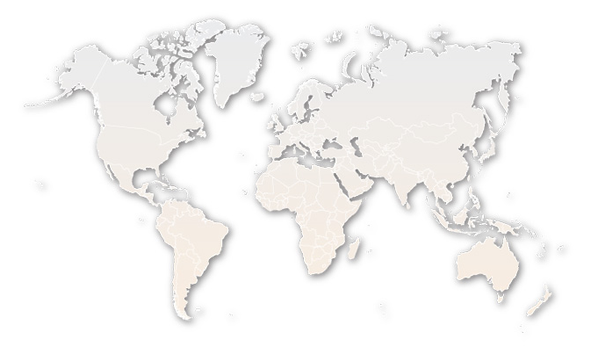

By: Parallel Imports Committee

Contents
Contents 2
Intro/Summary 6
Albania 7
Algeria 8
Angola 9
Anguilla 10
Argentina 11
Aruba 112
Australia 13
Austria 15
Bahrain 16
Bangladesh 18
Belgium 19
Belize 19
Bermuda 21
Bhutan 22
Bolivia 23
Bosnia And Herzegovina 24
Brazil 25
Bulgaria 26
Burundi 27
Canada 28
Cape Verde 30
Chile 31
China 32
Colombia 34
Costa Rica 35
Croatia 36
Cuba 37
Curaçao 38
Czech Republic 39
Denmark 40
Dominican Republic 41
Ecuador 42
Egypt 43
England and Wales 44
Finland 46
France 47
Gambia 48
Germany 49
Ghana 50
Grenada 51
Greece 52
Guatemala 53
Haiti 54
Honduras 55
Hong Kong 56
Hungary 58
India 59
Israel 60
Italy 61
Ireland 63
Jamaica 64
Japan 65
Kenya 66
Kuwait 67
Lebanon 68
Lithuania 70
Luxembourg 71
Macedonia 72
Malaysia 73
Malta 74
Mauritius 76
Mexico 77
Montenegro 78
Morocco 79
Myanmar 80
Mozambique 81
Nepal 82
Netherlands 83
New Zealand 84
Nicaragua 87
Nigeria 88
Norway 89
Pakistan 90
Panama 91
Paraguay 92
Peru 93
Philippines 94
Poland 95
Portugal 96
Qatar 97
Republic of Korea 98
Romania 100
Russia 101
Saint Martin 102
São Tomé and Principe 103
Serbia 104
Sierra Leone 105
Singapore 106
Slovakia 107
Slovenia 108
South Africa 109
Sri Lanka 110
Sudan 111
Suriname 112
Sweden 113
Switzerland 114
Taiwan 115
Thailand 116
Trinidad and Tobago 117
Tunisia 118
Turkey 119
Turks and Caicos Islands 120
Ukraine 121
United Arab Emirates (UAE) 122
United States of America 124
Uruguay 126
Venezuela 127
Vietnam 128
Yemen 129
Zambia 130
Zimbabwe 131

Intro/Summary
During the 2014 – 2017 Terms, INTA’s Parallel Imports Committee collected information from many countries located in North America, Europe, Central and Latin America, the Caribbean, Middle East and Africa, and the Asia-Pacific regions and produced this overview of the treatment of Parallel Imports (PI) worldwide as a resource for brand owners and practitioners. The Committee was able to obtain responses from 111 countries. This report contains the responses from those jurisdictions and although verified in each case, neither the PIC nor INTA can guarantee the accuracy of the information reproduced here.

When it comes to PI, the world is divided between jurisdictions with international exhaustion and jurisdictions with national/regional exhaustion. Exhaustion defines the geographic area a product has to have been released into with the authorization of the brand owner in order to exclude claims of trademark infringement. In other words, where international exhaustion is adopted, it is sufficient for the product to have been released into commerce anywhere in the world with the authorization of the brand owner, while national or regional exhaustion requires the brand owner to have explicitly agreed to the sale of the product in that particular jurisdiction or region, whereupon the product can no longer be considered to infringe the brand owner’s exclusive trademark rights. A hybrid approach is the one adopted by the US: while PI are generally legal and permitted, products that are “materially different” from the ones authorized for sale within the US by the same brand owner are considered infringing and can be stopped at the border. In the US, “material differences” can be any characteristic, quality, composition or look that would be considered important by the relevant consumers

The results of the PIC’s study reveal that while there seems to be a majority of jurisdictions under the international exhaustion regime, (e.g., China, Japan, India, Australia, Korea, Mexico, Argentina, Egypt, the UAE and Switzerland), some countries follow national exhaustion (for example Brazil and Russia). The European Union (and some smaller economic unions) applies a system of regional exhaustion by which parallel imports can travel freely within the E.U. (unless the products contain material differences that, for example, pose a risk to health or public order, in which case they could be prohibited), but cannot be imported from outside the European Union and the European Economic Area’s borders without the trademark owner’s consent.

The research also showed that despite not being widely known or publicized, some countries may not refer to “material differences” but do acknowledge that products that have undergone substantial modifications, or were damaged, or do not function in the import market, should not be permitted and therefore provide for some remedies by means of which brand owners may stop their import. .

INTA supports national exhaustion of trademark rights, but, recognizing that, in some countries, it may not be feasible to move from international to national exhaustion, INTA advocates for those countries to at least provide for the exclusion of parallel imports that are materially different from those products authorized for sale by the trademark owner in the domestic market. INTA’s Board Resolution on Parallel Imports is available on INTA’s website https://www.inta.org/Advocacy/Pages/AMaterialDifferencesStandardforInternationalExhaustionofTrademarkRights.aspx .

The Parallel Imports Committee wishes to thank all contributors of this guide for their support.


Albania
Type of Exhaustion | Exceptions to Exhaustion
National | If, without consent, goods are changed or impaired.
Assessment of Parallel Imports
Can Unauthorized Parallel Imports Be Prevented From Entering Country?

Applicable Legislation
158(1) of Albanian Industrial Property Law
Civil Litigation --- Request for Precautionary Measure. Customs May Detain Goods That Are Imported By A Non-Authorized Distributor.
Does Customs Support/Assist Trademark Owner With PI?
No, but customs may detain goods that are imported by a non-authorized distributor.

What Procedures Are Available Once PI’s Enter Country?

Civil litigation - Article 184. Unfair competition under Article 638 of Albania Civil Code.

What Remedies Are Available?

Seizure/destruction; seizure of containers and devices; cease and desist orders; damages and compensation; information on origin of goods; publication of judgment; fines and imprisonment.

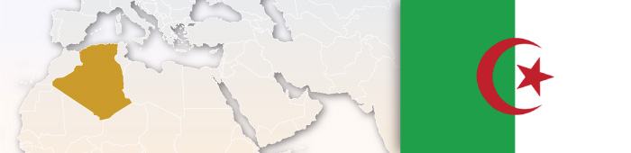

Algeria
Type of Exhaustion | Exceptions to Exhaustion
International
Assessment of Parallel Imports
Can Unauthorized Parallel Imports Be Prevented From Entering Country?
There seems no prevention offered in local Algerian laws as the country follows international exhaustion.
Does Customs Support/Assist Trademark Owner With PI’s?
Customs would not be able to provide any logical support as legally there are no restrictions imposed.

What Procedures Are Available Once PI’s Enter Country?

PI usually are not restricted and hence are sold freely in local markets.
What Remedies Are Available?

The local distributor can seek some redress from the authorities responsible for weights and measures and standardization of products.



Angola
Assessment of Parallel Imports

Type of Exhaustion | Exceptions To Exhaustion
National
Assessment of Parallel Imports
Can Unauthorized Parallel Imports Be Prevented From Entering Country?
To file a custom action application one can include all the available information (as detailed as possible) about the origin and distribution channels of the PI. It can be very efficient in PI cases. The owner can expect more inspections to the goods at customs and fast seizures of suspected PI.
Does Customs Support/Assist Trademark Owner With PI’s?
Yes.
What Procedures Are Available Once PI Enter Country?
Civil action. Criminal action. The proprietor of the trademark may request an administrative raid by the economic police to prevent the sales of PI.
What Remedies Are Available?
Seizure/destruction of goods; delivery of infringing articles; order to cease and desist including interim and final injunctions; damages or an account of profits but not both; often information as to origin of goods; judgments are publically available; in certain cases imprisonment

Anguilla
Type of Exhaustion | Exceptions To Exhaustion
International.
The principle of international exhaustion which applies to Community Trademarks i.e. the principle of the free flow of goods shall not apply where legitimate reasons for the proprietor to oppose further commercialization of the goods exists, especially where the condition of the goods is changed or impaired after they have been put on the market.
Assessment of Parallel Imports
Can Unauthorized Parallel Imports Be Prevented From Entering Country?
No.
Does Customs Support/Assist Trademark Owner With PI’s?
No.

What Procedures Are Available Once PI’s Enter Country?

Civil Litigation.
What Remedies Are Available?

None.



Argentina
Type of Exhaustion | Exceptions To Exhaustion
International | No.
Assessment of Parallel Imports
Can Unauthorized Parallel Imports Be Prevented From Entering Country?
It can be prevented through the Consumers Protection Act.
Does Customs Support/Assist Trademark Owner With PI’s?
There is an alarm system that can be used in order to notify trademark owners once their products are introduced into the country.

What Procedures Are Available Once PI’s Enter Country?

None
What Remedies Are Available?

a) Consumer Protection Act.
b) Unfair Competition Act (e.g., if the products are of poor quality and the parallel importer is trying to benefit from the prestige of the authorized licensee/ distributor and divert customers).
c) Taxes: in the event that taxes are not collected
Key Case Law: Union Vending Argentina S.A. vs. Saeco Argentina S.A. et al. The court action was based on unfair competition.


Aruba
Type of Exhaustion | Exceptions To Exhaustion
International | No
Assessment of Parallel Imports
Can Unauthorized Parallel Imports Be Prevented From Entering Country?
No.
Does Customs Support/Assist Trademark Owner With PI’s?
No.
What Procedures Are Available Once PI’s Enter Country?
None
What Remedies Are Available?
No other legal mechanism.
Key Case Law: There is no specific legislation on the matter and through jurisprudence the courts determined that classifying parallel-import, as a tort would not be in the best interest of the consumers. Especially considering the size of the market and the monopolistic consequences for the consumers if parallel import would to be classified as a tort.
.



Australia
Type of Exhaustion | Exceptions To Exhaustion
International | Only if the relevant trademark was applied to goods without the consent of the registered owner. Numerous cases have read "consent" narrowly, in favor of the trademark owner.
Assessment of Parallel Imports
Can Unauthorized Parallel Imports Be Prevented From Entering Country?
Section 123 of the Australian Trade Marks Act 1995 provides a defence to a claim for trade mark infringement if the trade mark has been applied to the goods by, or with the consent of, the registered owner of the trade mark. The effect of this provision is that parallel importation of genuine goods into Australia is generally permitted.

Some foreign trademark owners have assigned ownership of their Australian trademark registrations to Australian distributors to attempt to avoid application of the statutory defence relating to parallel imports. However this strategy is not risk free and introduces a number of other factors which should be considered before undertaking such a transfer of ownership of an Australian trademark registration. It is the only current mechanism by which parallel importation can be stopped in Australia.

Applicable Legislation
Trade Marks Act 1995
Does Customs Support/Assist Trademark Owner With PI?
Usually no, with limited exceptions. A Notice of Objection may be lodged with the Australian Border Force (the Federal Government agency that operates the Customs regime) to stop the importation of goods which infringe a registered trade mark. Sometimes this may temporarily obstruct unauthorized parallel imports; however, once the ABF is aware that the goods are genuine, they will generally be released to the importer unless the trade mark owner can satisfy the ABF that the relevant trade mark was not affixed to the goods with the consent of the Australian trade mark owner. This is often a question of fact depending on the circumstances of how the mark was affixed and the nature of the Australian trade mark owner's consent.

What Procedures Are Available Once PI’s Enter Country?

Additional Comments
1. Numerous recent cases have applied the defense to parallel imports narrowly, in favor of the trademark owner and against the importer.

2. Some foreign trademark owners have assigned ownership of their Australian trademark registrations to Australian distributors to attempt to avoid application of the statutory defense relating to parallel imports. However this strategy is not risk free and introduces a number of other factors which should be considered before undertaking such a transfer of ownership of an Australian trademark registration.
There are no intellectual property remedies available once the goods are in the country, unless there is an Australian trade mark owner which can argue that the goods infringe its registered trade mark. The Australian Consumer Law as found in Schedule 2 to the Competition and Consumer Act 2010 (Cth) also protects brand owners where the parallel importer makes a false representation that the goods have a performance characteristic, use, benefit, warranty, guarantee or country of origin information that they do not have. In addition, parallel importers are prevented by the Australian Consumer Law from making false representations that they or their goods have a trade connection with or endorsement by brand owners.

What Remedies Are Available?

If trade mark infringement is established, then the court has the power to grant an injunction and either damages or an account of profits. If the defence under s.123 of the Trade Marks Act is made out, then no remedies will be granted.

Key Case Law (trademarks):
Scandinavian Tobacco Group Eersel BV v Trojan Trading Company Pty Ltd [2016] FCAFC 91; Lonsdale Australia Limited v Paul's Retail Pty Ltd [2012] FCAFC 130; QS Holdings Sarl v Paul's Retail Pty Ltd no. 2 [2011] FCA 1038; Paul's Retail Pty Ltd v Sporte Leisure Pty Ltd [2012] FCAFC 51; E and J Gallo Winery v Lion Nathan Australia Pty Ltd (2010) 241 CLR 144; Transport Tyre Sales Pty Ltd v Montana Tyres Rims & Tubes Pty Ltd (1999) 93 FCR 421

Key Case Law (Consumer Law): Star Micronics Pty Ltd v Five Star Computers Pty Ltd (1991) 22 IPR 473



Austria
Type of Exhaustion | Exceptions To Exhaustion
Regional EU-wide (+ material differences element) | If there is no consent, and the trademark owner has a reasonable justification for opposing the sale of the goods, i.e., if goods are altered or deteriorated.
Assessment of Parallel Imports
Can Unauthorized Parallel Imports Be Prevented From Entering Country?
Civil litigation; criminal action if there is intent; sometimes criminal tax proceedings.

Does Customs Support/Assist Trademark Owner With PI?
No, only counterfeit. If PI goods are seized by customs (and turn out not to be counterfeit), one can try to obtain an interim injunction granting the seizure of the goods in the civil courts.

What Procedures Are Available Once PI Enter Country?
Applicable Legislation
Section 10b, subsection 1 and 2 of the Trademark Act.

Civil litigation; criminal action if there is intent.

What Remedies Are Available?

Seizure/destruction; seizure of containers and devices; cease and desist orders; damages and compensation; information on origin of goods; publication of judgment; fines and imprisonment.

Type of Exhaustion | Exceptions to Exhaustion
International | Possible exceptions include already restricted or prohibited goods and essential goods.

Bahrain
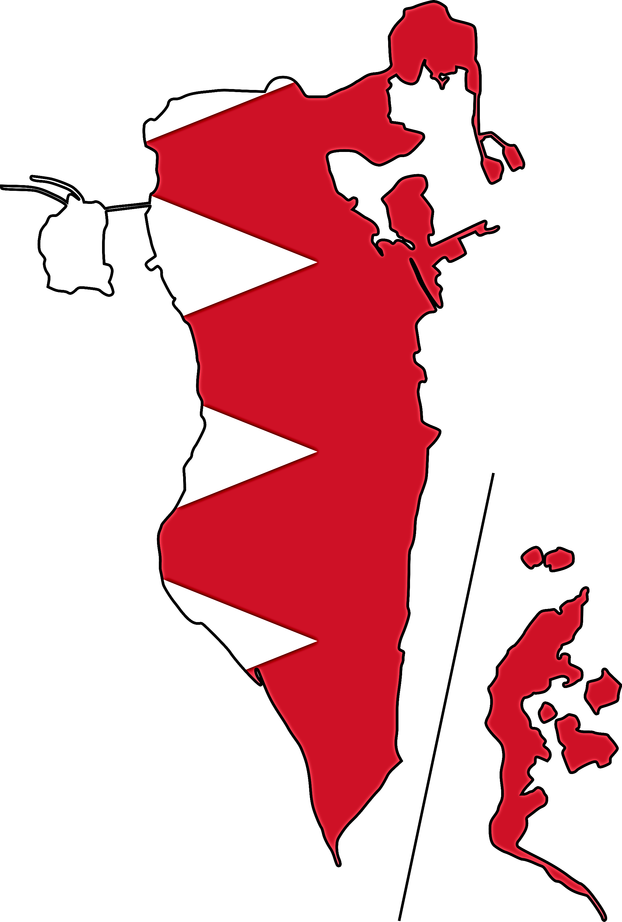
Assessment of Parallel Imports
Can Unauthorized Parallel Imports Be Prevented From Entering Country?
Additional Comments
"The law is still developing in this jurisdiction and it will be a matter of time for the country to align its import regulations and agency laws to restrict the incoming of parallel imported goods. Moreover, they also need to strictly implement the law that’s presently available so that parallel imports may be restrained with the aid of prevalent commercial law provisions.

Bahrain typically follows the doctrine of international exhaustion of rights, by way of which, once the product under a mark is circulated in the market, the IP rights of commercial exploitation ceases to exist. Article 44 (2) of the Trademark law mentions that none of the enforcement provisions are applicable if products already circulated in the market in the country of export by the trademark owner or at its consent. Further, the Commercial law also provides under article 67 (1) that "The name or trade name of the seller may not be put on products imported from a country other than that where the sale is carried out". This makes it difficult to restrain PI’s from being restrained to enter the market as the country of origin is not being mentioned."
Given that the Bahrain local laws are subject to international exhaustion of rights, the brand owners do not have rights to prevent entry of parallel imports in the local markets. However, as a part of contractual obligation with specific clauses being mentioned in exclusive agency agreements, exclusive agents may restrain the import of goods in the country by a third party. Further, the commercial law Decree No. 7 of 1987 provides, that where the quantity, measurements, weight, volume, size, origin or the ingredients used in its composition, are of the nature which affect the valuation of the product, the Minister of Commerce may issue a resolution prohibiting the import, sale or offering for the sale of such products unless they carry one or more the foregoing particulars. In view of this provision, parallel imports may be restrained on the basis of commercial laws.

Does Customs Support/Assist Trademark Owner With PI?
While the customs law in Bahrain has specific provisions to take action against counterfeits and against prohibited/restricted goods, there is nothing specifically mentioned in the law for parallel imported goods.

What Procedures Are Available Once PI Enter Country?

None.

What Remedies Are Available?

The only remedy to secure exhaustion of IP rights in Bahrain is by way of contractual obligations. The local courts usually consider the breach on restriction to export by a purchaser in the same manner as any other contractual obligation between the parties. Accordingly, the court passes order restraining unauthorized exports and/or imports and assesses damages for such breach (loss of profit and damage sustained). Article 12 of the Agency Law (amended in 1998) states "...the Minister of Commerce may prohibit / ban admission of the goods, properties or continuation of services if the public interest so requires.” If a parallel import needs to be restrained, a petition may be filed at the Ministry on the grounds of public interest and the outcome would be completely discretionary to the Ministry.

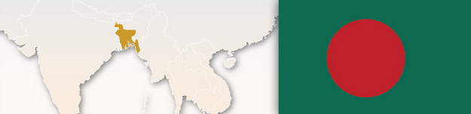

Bangladesh
Type of Exhaustion | Exceptions To Exhaustion
National
Assessment of Parallel Imports
Can Unauthorized Parallel Imports Be Prevented From Entering Country?
Yes. In case of import of branded goods registered in Bangladesh, an intellectual property certificate by the intellectual property holder of the exporting country in favour of the concerned branded goods is required to be submitted to the Customs Authority, in absence of which the branded good will not be allowed to enter the Country.

Applicable Legislation
Trademarks Act, 2009
Import Policy Order 2012-2015

Does Customs Support/Assist Trademark Owner With PI?
Yes. Upon receiving a complaint from the original owner of the intellectual property rights and in the absence of an IP Certificate, the Customs can refuse clearance of the PI’s.

Additional Comments
Recently, a District Court in Dhaka ruled that the act of parallel import also constitutes infringement of trademarks under the Trademarks Act, 2009.
What Procedures Are Available Once PI Enter Country?
Civil Litigation

What Remedies Are Available?
Suit may be filed by the trademark owners for confiscation / restraining of the parallel imports.



Belgium
Type of Exhaustion | Exceptions to Exhaustion
Regional EU-wide  (+ material differences element) | If there is no consent and the trademark owner has a reasonable justification for opposing the sale of the goods, i.e., if goods are altered or deteriorated.
Assessment of Parallel Imports
Can Unauthorized Parallel Imports Be Prevented From Entering Country?
No.
Does Customs Support/Assist Trademark Owner With PI?
No.

What Procedures Are Available Once PI Enter Country?

Civil litigation; criminal action if there is intent.

What Remedies Are Available?

Seizure/destruction; seizure of containers and devices; cease and desist orders; damages and compensation; information on origin of goods; publication of judgment; fines and imprisonment.

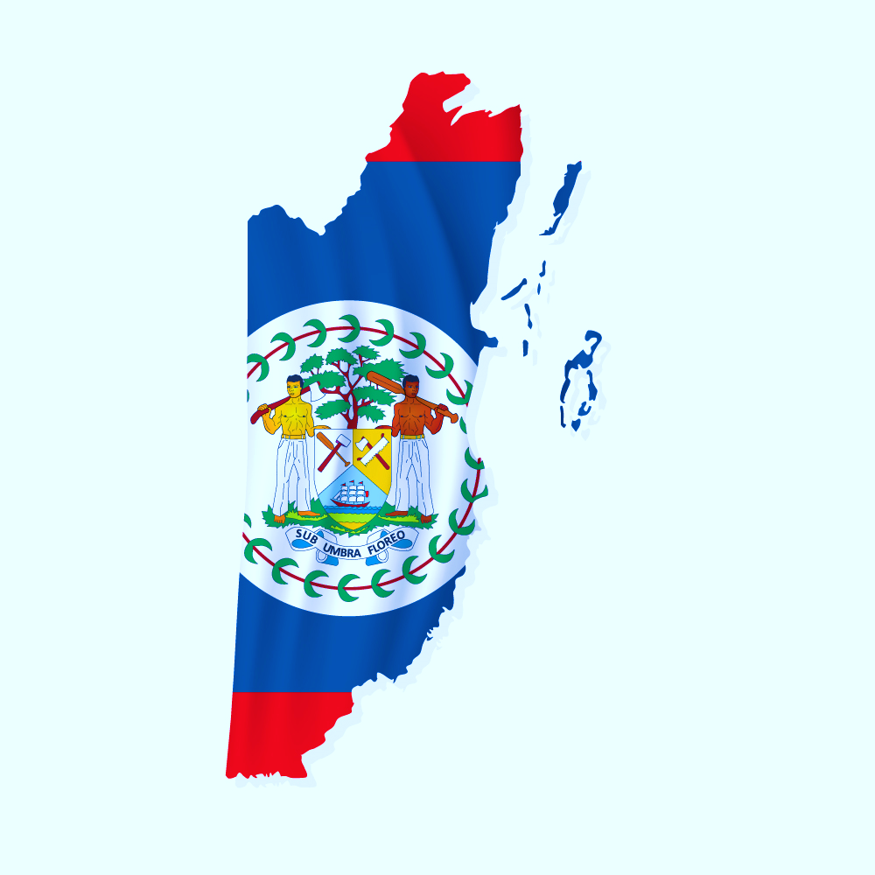
Belize
Type of Exhaustion | Exceptions to Exhaustion
Regional (CARICOM) | Yes  Where there exist legitimate reasons for the proprietor to oppose further dealings in the goods (in particular, where the condition of the goods has been changed or impaired after they have been put on the market).
Assessment of Parallel Imports
Can Unauthorized Parallel Imports Be Prevented From Entering Country?
No, unless exceptions.
Does Customs Support/Assist Trademark Owner With PI?
No, but there are certain situations where the import of UI’s may be challenged.

What Procedures Are Available Once PI Enter Country?

There are no specific provisions for parallel imports n in the Belize Trade Marks Act257 however Section 27 of the Act addresses exhaustion:
(1) A registered trademark is not infringed by the use of the trademark in relation to goods which have been put on the market in the CARICOM Single Market and Economy under that trademark by the proprietor or with his consent.
(2) Subsection (1) does not apply where there exist legitimate reasons for the proprietor to oppose further dealings in the goods (in particular, where the condition of the goods has been changed or impaired after they have been put on the market).

What Remedies Are Available?

Where Section 27 (2) applies, remedies could include forfeiture of goods, fines not exceeding fifteen thousand dollars or to imprisonment for a period not exceeding ten years

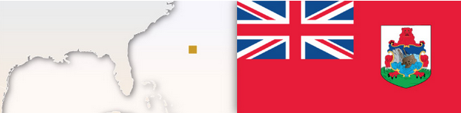
Type of Exhaustion | Exceptions to Exhaustion
Regional | Yes

Bermuda
Assessment of Parallel Imports
Can Unauthorized Parallel Imports Be Prevented From Entering Country?
No.
Additional Comments
A recorded license agreement is required to take action against third parties.
Does Customs Support/Assist Trademark Owner With PI?
No.

What Procedures Are Available Once PI Enter Country?

Trademark infringement action if the product (or its packaging) has undergone a change, alteration, or deterioration.

What Remedies Are Available?

Based on private contract law. Dealers, distributors and agents with contractual agreements may avail themselves only of remedies under the individual contract/dealership agreements.

Key Case Law: No, but Bermuda courts may take notice of decisions from other Commonwealth jurisdictions; especially, from decisions in England where the Bermuda Legislation and Common Law are similar.

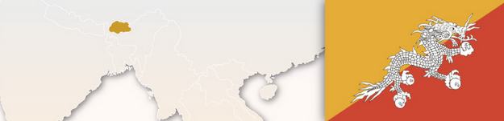

Bhutan
Type of Exhaustion | Exceptions to Exhaustion
National | No.
Assessment of Parallel Imports
Can Unauthorized Parallel Imports Be Prevented From Entering Country?
Yes. Section 28(3) of the Industrial Property Act of the Kingdom of Bhutan, 2001 refers to national exhaustion.
Applicable Legislation
The Industrial Property Act of the Kingdom of Bhutan, 2001
Does Customs Support/Assist Trademark Owner With PI?
Yes.

What Procedures Are Available Once PI Enter Country?

The trade mark owner can file a complaint with the customs and with the office concerned in respect of a particular sector against PI. Eg. for drugs complaint can be filed with the Ministry of Health.
Additional Comments
Presently Bhutan recognizes National Exhaustion. However, the country proposes to migrate to International Exhaustion shortly.

What Remedies Are Available?

Under the existing law, PI’s tantamount to infringement, and the trade mark owner can seek the remedies which are available for trade mark infringement.


Bolivia
Type of Exhaustion | Exceptions to Exhaustion
International | Only when the product (or its packaging) has undergone a change, alteration, or deterioration.
Assessment of Parallel Imports
Can Unauthorized Parallel Imports Be Prevented From Entering Country?
No.
Does Customs Support/Assist Trademark Owner With PI?
Applicable Legislation
Decision 486 of Andean Community (article 158)
No.

What Procedures Are Available Once PI Enter Country?

Action can be taken before customs to prevent the importation. Court actions against the parallel importer are also available.
What Remedies Are Available?

Trademark infringement action if the product (or its packaging) has undergone a change, alteration, or deterioration.

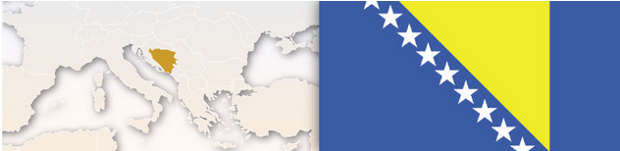

Bosnia And Herzegovina
Type of Exhaustion | Exceptions to Exhaustion
International | Where there are justified reasons for the owner to oppose further commercialization, i.e., if the goods have been changed or impaired.
Assessment of Parallel Imports
Can Unauthorized Parallel Imports Be Prevented From Entering Country?
Only if the goods are impaired, and if that is the case, the brand owner may file a Customs Monitoring Request in accordance with Article 94 of Trademark Law with customs; sometimes via civil litigation.
Does Customs Support/Assist Trademark Owner With PI?
If there is an issue with the goods, a brand owner may can file a Customs Monitoring Request with customs, which may result in a temporary hold for the goods.

Applicable Legislation
Article 51 of Trademark Act
What Procedures Are Available Once PI Enter Country?

Civil litigation under article 80 of the Trademark Law

What Remedies Are Available?

Seizure/destruction of infringing goods, containers and devices; orders to cease and desist; damages/compensation; information pertaining to the origin of the goods; publication of the judgment; fines and imprisonment.

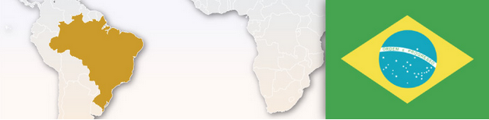

Brazil
Type of Exhaustion | Exceptions to Exhaustion
International
Article 132 – The owner of a mark shall not: (…) III – prevent free circulation of products placed in the internal mark by itself or by a third party with its consent, except for the provisions of paragraphs 3rd and 4th of article 68
Assessment of Parallel Imports
Can Unauthorized Parallel Imports Be Prevented From Entering Country?
Yes, if the product’s mark is registered in Brazil and licensed with exclusivity to a local company and the corresponding license agreement is duly recorded with the Brazilian Trademark Office and also if the products do not meet the requirements of the Brazilian Consumer Law. If that occurs, the products cannot be marketed within the country.

Does Customs Support/Assist Trademark Owner With PI?
Yes.

What Procedures Are Available Once PI Enter Country?

Civil Litigation.
What Remedies Are Available?

They may commence court proceedings against the parallel importer on the grounds of unfair competition and illicit enrichment.
Applicable Legislation
Article 132, III, of the Brazilian Industrial Property Law (Federal Law No. 9,279/96)
Key Case Law: DIAGEO BRANDS BV vs. GAC IMP. E EXP. LTDA.: On December 18, 2012, the Third Panel of Justices of the Superior Court of Justice issued a decision expressly confirming that the Brazilian Industrial Property Law states that the trademark owner or its licensee has the right to prevent the importation of products without his consent.
BROTHER INTERNATIONAL CORPORATION DO BRASIL LTDA. vs PLENA COMERCIAL ATACADISTA: on April 8, 2008, Ninth Panel of Judges of Private Law of Court of Appeals of the State of São Paulo issued a decision ruling that the trademark owner that has an exclusive licensee in the country and this license is recorded with the Brazilian Trademark Office has the right to block parallel imports of the branded product.

Bulgaria
Type of Exhaustion | Exceptions to Exhaustion
Regional EU-wide  (+ material differences element) | Without the owner's consent, where there is a legitimate reason to oppose further commercialization of the goods, i.e., where the goods are changed or impaired after they are put on the market.
Assessment of Parallel Imports
Can Unauthorized Parallel Imports Be Prevented From Entering Country?

Civil Litigation.
Does Customs Support/Assist Trademark Owner With PI?
No.
Applicable Legislation
Art. 15, para. 2 LMGI; Art. 35, para 1 Law on Protection of Competition (LPC)

What Procedures Are Available Once PI Enter Country?

Civil infringement action: (article 76 of the Bulgarian LMGI); unfair competition action (Article 29-35 of the Bulgarian LPC); administrative action filed with the Bulgarian PTO (article 81 of the Bulgarian LMGI).

What Remedies Are Available?

Seizure/destructions of goods and devices like containers; order to cease and desist; compensation for all material and non-material damages suffered and lost profits; information on place of origin of goods; publication of the judgment, including at the expense of the infringer on national TV.

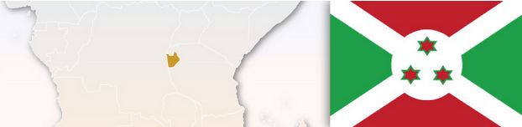

Burundi
Assessment of Parallel Imports
Can Unauthorized Parallel Imports Be Prevented From Entering Country?
Type of Exhaustion | Exceptions to Exhaustion
International
There seem no prevention offered in local Burundian laws as the country follows international exhaustion.
Does Customs Support/Assist Trademark Owner With PI?
Customs would not be able to provide any logical support if legally there are no restrictions imposed.

What Procedures Are Available Once PI Enter Country?

PI’s usually are not restricted and hence are sold freely in local markets.

What Remedies Are Available?

The local distributor can seek some redress from the authorities responsible for weights and measures and standardization of products.
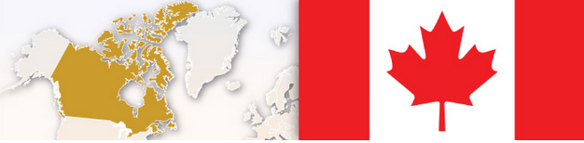

Canada
Assessment of Parallel Imports
Type of Exhaustion | Exceptions to Exhaustion
Generally international exhaustion, but there are exceptions. Government authorities may prevent product importation that does not comply with federal or provincial regulations. Under trademark law, infringement may be alleged if the owner of the Canadian trademark rights is different from the manufacturer/seller and did not use or authorize use of the mark on the imported goods. Alternatively, passing off may be alleged if the imported goods are materially different from the domestic goods.
Material Differences Standard
Can Unauthorized Parallel Imports Be Prevented From Entering Country?
Applicable Legislation
Trademarks Act, R.S.C., 1985, c T-13, s. 19, 20, 22; Copyright Act R.s.C. 1985, c.C-42; Criminal Code R.S.C. 1985, c. C-46; Customs Act, R.S.C. 1985, c. 1 (2nd. Supp)

Under trademark law - provided certain conditions are met - a court may order the interim custody of goods. A court may also prohibit the future importation of such goods. Trademark holders may also seek an injunction against the importation of gray market wares on the basis that the gray market wares depreciate the goodwill associated with the trademark (although this is difficult to obtain). The Customs Act also enables the detention and disposition of imported goods prohibited by an order made under the Trademarks Act. However, these remedies are not always practicable due to the evidence and difficulties required to obtain a court order. Under trademark law, a court may order to detain goods that are about to be imported into Canada, or have been imported into Canada but not yet released, the distribution of which would be contrary to the Trademarks Act, if they were made in Canada by the importer. In rare cases, a government authority could prevent importation of goods that do not comply with regulations (more likely if there is a serious health/safety issue). It is up to the government authority to take such steps.

Does Customs Support/Assist Trademark Owner With PI?
New remedies under Canadian trademark and copyright laws, as well as new border measures, were enacted in 2016. Trademark owners have the opportunity to register trademarks and copyrights with customs. The regime provides for a time limited detention period for goods pending the initiation of a court action by the rights holder (failing which the goods will be released). However, the legislation is directed to counterfeit goods (it specifically exempts parallel import products). CBSA may also seize parallel import goods under the Customs Act for failing to meet regulatory requirements.

What Procedures Are Available Once PI Enter Country?

Possible procedural avenues include:
civil litigation, usually in Federal Court (sometimes in provincial court); criminal action (rarely); and government authority intervention.

Additional Comments
Section 28(3) refers to international exhaustion. No precedent on parallel imports.
What Remedies Are Available?

Possible procedural avenues include: civil litigation, usually in Federal Court (sometimes in provincial court); criminal action (rarely); and government authority intervention.

Key Laws: For trademark - Dupont of Canada Ltd. v. Nomad Trading Co. (1968) 55 CPR 97; Consumers Distributing Co v Seiko Time Canada Ltd. (1984) 1 CPR (3d) 1; H.J. Heinz Co of Canada ltd. v. Edan foods Sales Inc. 91991 15 CPR (3d) 213; Havana House Cigar & Tobacco Merchants Ltd. v. Skyway Cigar Store (1998) 81 CPR (3d) 203; For copyright - Clarke, Irwin & Co Ltd. v C. Cole 7 Co Ltd. [1960] OR 117; Fly by Night Music Co. Ltd. v. Record Warehouse Ltd. 91975 20 CPR (2d) 263l Euro-Excellence Inc. v. Kraft Canada Inc. 2007 SCC 37

Cape Verde
Type of Exhaustion | Exceptions To Exhaustion
National | No.
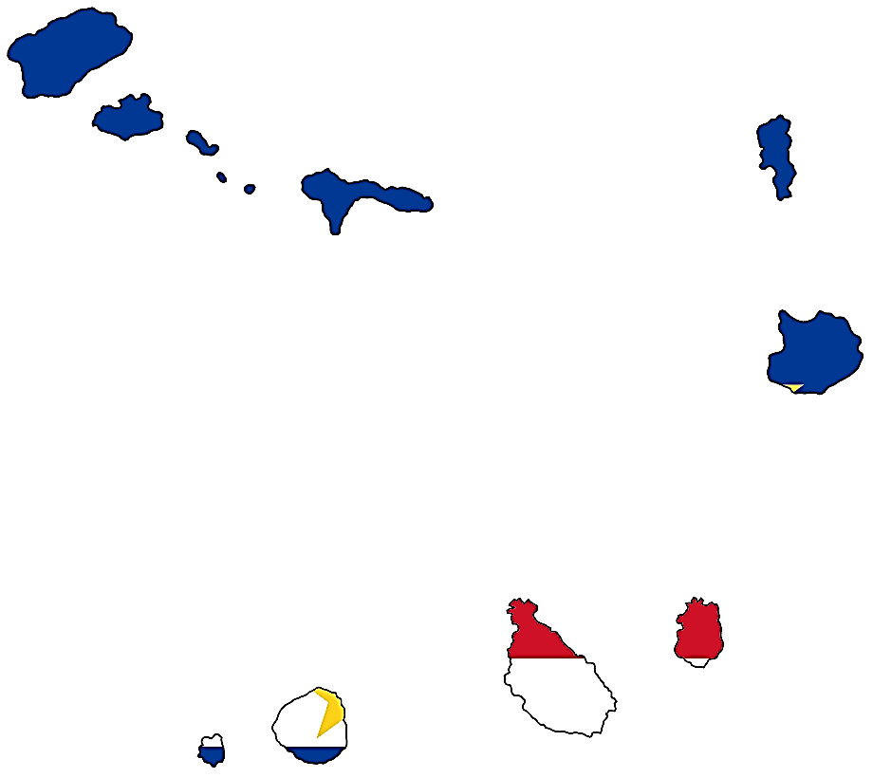
Assessment of Parallel Imports
Can Unauthorized Parallel Imports Be Prevented From Entering Country?
To file a custom action application one can include all the available information (as detailed as possible) about the origin and distribution channels of the PI. It can be very efficient in PI cases. The owner can expect more inspections to the goods at customs and fast seizures of suspected PIs.
Does Customs Support/Assist Trademark Owner With PI?
Yes.
What Procedures Are Available Once PI Enter Country?
Civil action and Criminal action. The proprietor of the trademark may request an administrative raid by the economic police to prevent the sales of PI.
What Remedies Are Available?

Seizure/destruction of goods; delivery of infringing articles; order to cease and desist including interim and final injunctions; damages or an account of profits but not both; often information as to origin of goods; judgments are publically available; in certain cases imprisonment

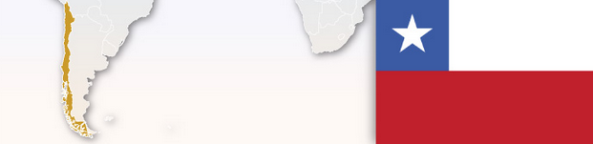

Chile
Assessment of Parallel Imports
Can Unauthorized Parallel Imports Be Prevented From Entering Country?
No. It may be possible using other laws such as sanitary regulations and consumer protection laws.

Type of Exhaustion | Exceptions to Exhaustion
International | No.
Does Customs Support/Assist Trademark Owner With PI?
No. Customs only intervenes when the products are counterfeited.

What Procedures Are Available Once PI Enter Country?

No.

What Remedies Are Available?

Where the products do not meet the Chilean regulations, other actions such as tax, sanitary regulations or consumer protection can be pursued.

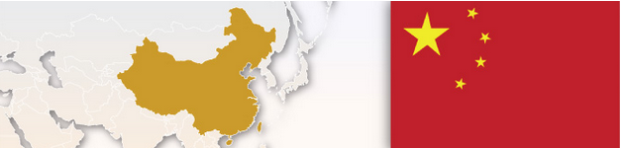

China
Type of Exhaustion | Exceptions to Exhaustion
Generally International Exhaustion, although the courts have sometimes recognized exceptions on the basis of false/locally incorrect labelling or problems with product quality.

There is a divergence between authorities with decisions based on different facts. In Lux, the Guangzhou Intermediate Court treated parallel imports as counterfeits, as the importer could not prove that the products were made under the consent of the brand owner. In Michelin, the Chanqsha Intermediate Court considered the sale of unauthorized Michelin products as parallel imports and found trademark infringement, due to the fact the importer had not obtained proper product certification for the imported goods; and the Court believed these goods could damage the brand owner's reputation if they had quality and safety problems.

Assessment of Parallel Imports
Can Unauthorized Parallel Imports Be Prevented From Entering Country?
There has been inconsistent decision and opinions among the people’s courts regarding the legality of parallel imports in China, and because there are relatively few parallel import cases comparing to other hotly debated trademark issues, the Supreme People’s Court has yet to publish any opinions or guidance on this issue. This leaves foreign brand owners who are troubled by parallel imports to only the few influential precedents that may be considered if the court hearing the case exercises its discretion.

Whether unauthorized parallel imports can be prevented from entering the country is still in the air. Courts around China are likely to decide each case based on the facts and the applicable laws, namely, the anti-unfair competition law or the trademark law. Before this issue can be firmly tight to the trademark law, some courts are more willing to apply the anti-unfair competition law, while some courts are willing to find parallel imports as trademark infringement and prevent the goods from entering the country.
Does Customs Support/Assist Trademark Owner With PI?
Applicable Legislation
China Trade Mark Law 2014 & Regulation on the Implementation of the Trademarks Law 2014; Regulation on the Customs Protection of Intellectual Property Rights 2010 & Rules for Implementing the Regulation on the Customs Protection of Intellectual Property Rights 2009.

There is no specific laws or regulations concerning PI’s in China. Therefore, China Customs is not empowered to stop importations of PI's but it may seize goods that violate Trademark Law or Regulation on the Customs Protection of Intellectual Property Rights.

What Procedures Are Available Once PI Enter Country?

Administrative Procedures and Civil Litigation.

What Remedies Are Available?
Order to cease import and sale of PI products, and claim damages.
Key Case Law: Shanghai Unilever Co., Ltd. v. Guanqzhou Economic & Technical Development Zone Business Import and Export Trading Company, the Guanqzhou Intermediate People's Court (1999); Beinjin Fahuayilin Trading Co., Ltd. v. Beijing Shijihenqyuan Science and Trading Co., Ltd. & Chonqqinq Grand Capital Pacific Department Store Ltd., the Beijing Second Intermediate People's Court (2000); Hefei Unilever Detergent Ltd. v. Fangchenggang Foreign Trade Co. and Liang Qingguang, Fangchenggang Intermediate People 's Court of Guangxi Zhuang Autonomous Region (2002), Michelin Group v. Tan Guoqianq & Ou Can, Michelin Group v. Hu Yaping, Chanqsha Intermediate People's Court (2009), Victoria Secret Stores Brand Management, Inc. v. Shanghai Jingtian Clothing Co., Ltd., Shanghai Second Intermediate Court (2012), Absolut Co. v. Suzhou Longxinyuan Liquor Co., Ltd., Suzhou Intermediate Court (2013), Shanghai Maisi Investment Management Co., Ltd. v. Victoria Secret Stores Brand Management, Inc., Shanghai High Court (2014), J.P. Chenet v. Muti International Trading

Additional Comments
1. Although China adopts International Exhaustion as the main doctrine to deal with PI issues, the judicial reality is ambiguous due to the absence of specific legislations regulating this problem or definitive case decisions.
2. The doctrine governing the PI issue is a reflection of a country's national policy and economic trend. Chinese authorities are cautious when it comes to PI cases. Decisions will be made based on the facts of the specific case, with consideration of balancing the rights and interests between the consumers and trademark owners.


Colombia
Type of Exhaustion | Exceptions to Exhaustion
International

Assessment of Parallel Imports
Can Unauthorized Parallel Imports Be Prevented From Entering Country?
In Colombia, parallel imports are allowed and according to applicable trademark law, International Exhaustion of Rights is applied. In general, there is no exception to this rule. In Colombia, there is no law which expressly regulates this exhaustion of rights in cases related to copyrights. In Colombia, according to Decision 486, International Exhaustion of Rights is applicable in cases related to patents The same is applicable for design rights
Additional Comments
Section 28(3) refers to international exhaustion. No precedent on parallel imports.

According to Decree 1313 of 2010 (which was excluded from the general derogation of Decree 780 of 2016), public and private entities must be authorized to perform parallel imports of medicines and medical devices. However, in order to obtain said authorization, the medicines and medical devices to be imported must have a Marketing Authorization (MA) issued by INVIMA (Colombian Regulatory Authority) and must be produced by the manufacturer authorized in the referred MA.

Does Customs Support/Assist Trademark Owner With PI?
No.

What Procedures Are Available Once PI Enter Country?
There is no procedure to prevent an event which is not prohibited by law.
What Remedies Are Available?

N/A.
Applicable Legislation
Industrial Property (Decision 486/2000 CAN)
Trademarks: Article 158.- Trademark registration shall not confer on the owner the rights to prevent third parties from engaging in trade in a product protected by registration once the owner of the registered trademark or another party with the consent of or economic ties to that owner has introduced that product into the trade of any country, in particular where any such products, packaging or packing as may have been in direct contact with the product concerned have not undergone any change, alteration, or deterioration. Patents: Article 54.- A patent shall not confer on its owner the right to proceed against a third party making commercial use of a product protected by a patent once that product has been introduced into the commerce of any country by the owner or another person authorized by the right holder or with economic ties to that patent owner.
Industrial Designs: Article 131. - Registration of an industrial design shall not confer the right to proceed against a third party who makes commercial use of a product incorporating or reproducing the design once it has been introduced into the commerce of any country by the right holders or another person authorized by them or with economic ties to those right holders.

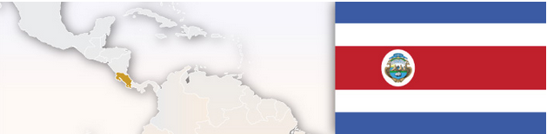

Costa Rica
Type of Exhaustion | Exceptions to Exhaustion
International

No Exceptions only occur where the goods are acquired through illegal means.

Assessment of Parallel Imports
Can Unauthorized Parallel Imports Be Prevented From Entering Country?
No.
Does Customs Support/Assist Trademark Owner With PI?
No. There is no support from Customs for trademark owners. At present, customs recordal is not permitted, though there is pending legislation to create an official list of IP owners.

What Procedures Are Available Once PI Enter Country?

None. Any challenge to the import of PI’s would have to be through other avenues, such as regulatory, compliance with labelling, conditions of goods or tax issues.

What Remedies Are Available?

None.

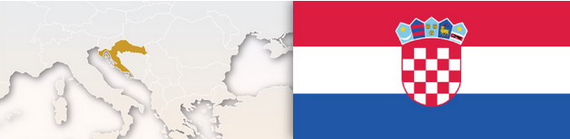

Croatia
Type of Exhaustion | Exceptions to Exhaustion
After accession of Croatia to the EU, Regional EU-wide (+ material differences element) | Without consent, where there are justified reasons to oppose commercialization especially where the goods are changed or impaired.
Assessment of Parallel Imports
Can Unauthorized Parallel Imports Be Prevented From Entering Country?
Although border measures do not generally apply to PI’s, customs has the authority to detain infringing goods and it can be helpful to apply for customs border measures (including import routes, schedules, and local distributor). Customs will likely temporarily restrain the goods, as it will ask for confirmation as to whether the goods are counterfeit. Also civil litigation is possible. There are misdemeanor/criminal liability provisions for trademark infringement, but we are not aware of any UPI cases under this type of proceeding, and the burden of proof is very high.
Does Customs Support/Assist Trademark Owner With PI?
Although border measures do not generally apply to PI’s, customs has the authority to detain infringing goods and it can be helpful to apply for customs border measures (including import routes, schedules, and local distributor). Customs will likely temporarily restrain the goods and it will ask for confirmation as to whether the goods are counterfeit.

What Procedures Are Available Once PI Enter Country?
Civil litigation; criminal action for trademark infringement is possible but unlikely for PI.

What Remedies Are Available?
Possible seizure/destruction; cease and desist orders; damages/compensation; information concerning origin of goods; publication of judgment (Articles 76-79 of the Trademarks Act).

Cuba
Assessment of Parallel Imports
Can Unauthorized Parallel Imports Be Prevented From Entering Country?
No.
Does Customs Support/Assist Trademark Owner With PI?
No.
What Procedures Are Available Once PI Enter Country?
Type of Exhaustion | Exceptions to Exhaustion
International | None
None
What Remedies Are Available?
None.
Key Case Law:


Curaçao
Assessment of Parallel Imports
Can Unauthorized Parallel Imports Be Prevented From Entering Country?
No.
Does Customs Support/Assist Trademark Owner With PI?
No.

What Procedures Are Available Once PI Enter Country?
Type of Exhaustion | Exceptions to Exhaustion
International | None

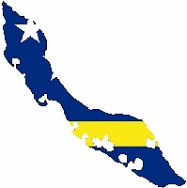
None
What Remedies Are Available?

None

Key Case Law: The courts determined that classifying parallel-import, as a tort would not be in the best interest of the consumers in light of the size of the market and the monopolistic consequences for the consumers if it were to be classed as a tort.

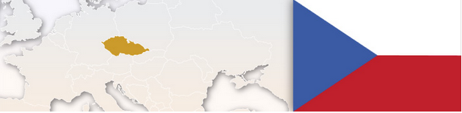

Czech Republic
Type of Exhaustion | Exceptions to Exhaustion
Regional EU-wide (+ material differences element) | As laid out in Article 7 of the EC Trademark Directive
Assessment of Parallel Imports
Can Unauthorized Parallel Imports Be Prevented From Entering Country?
Civil litigation; possibly criminal offence of trademark infringement, but it is highly unlikely to be pursued by police and public prosecutor unless there are special reasons to do so.
Does Customs Support/Assist Trademark Owner With PI?
No.

What Procedures Are Available Once PI Enter Country?

Civil Litigation.
What Remedies Are Available?

Possible seizure/destruction, but less likely to be granted than counterfeiting cases; cease and desist orders; damages/compensation; information concerning origin of goods; publication of judgment.



Denmark
Type of Exhaustion | Exceptions to Exhaustion
Regional EU-wide
(+ material differences element)

Without consent of the owner, if there is a legitimate reason for the proprietor to oppose further commercialization of the goods, especially in cases where the condition of the goods have been changed or impaired after they have been put to market. There are special considerations for repackaging/labeling of pharmaceutical products that can impact whether the product can be marketed.
Assessment of Parallel Imports
Can Unauthorized Parallel Imports Be Prevented From Entering Country?
Civil litigation and preliminary injunctions granted by a bailiff; criminal action may be possible.

Does Customs Support/Assist Trademark Owner With PI?
No.

What Procedures Are Available Once PI Enter Country?

Civil litigation and preliminary injunctions granted by a bailiff; criminal action may be possible.

What Remedies Are Available?

Seizure/destruction; seizure of containers and devices; cease and desist orders; damages and compensation; information on origin of goods; publication of judgment; fines and imprisonment (Article 41 to 44 of the Danish Trademark Act).
Applicable Legislation
Article 6(1) of the Danish Consolidate Trademark Act No. 109

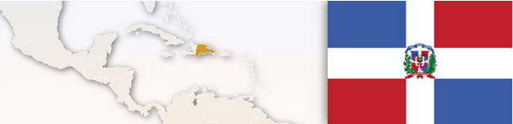
Dominican Republic
Type of Exhaustion | Exceptions to Exhaustion
International | No.
Assessment of Parallel Imports
Can Unauthorized Parallel Imports Be Prevented From Entering Country?
Applicable Legislation
Parallel import activities are permitted in the Dominican Republic in view of the free circulation principle in its Constitution.
No.
Does Customs Support/Assist Trademark Owner With PI?
No.

What Procedures Are Available Once PI Enter Country?

None.

What Remedies Are Available?

Additional Comments
No specific PI protection but proprietor may trademark infringement might be applicable where product (or its packaging) has undergone a change, alteration or deterioration. Alternatively, other avenues include breach of contract or in the case of products for human or animal consumption, a breach of the sanitary registration regulations.

None.


Type of Exhaustion | Exceptions to Exhaustion
International | Only when the product (or its packaging) has undergone a change, alteration, or deterioration.

Ecuador
Assessment of Parallel Imports
Can Unauthorized Parallel Imports Be Prevented From Entering Country?
No.
Does Customs Support/Assist Trademark Owner With PI?
No.
Applicable Legislation
Decision 486 of Andean Community (article 158)

What Procedures Are Available Once PI Enter Country?

None.

What Remedies Are Available?

No.

Additional Comments
Remedies are also available against violations of sanitary registration regulations. Furthermore, there may be remedies under the antitrust law.

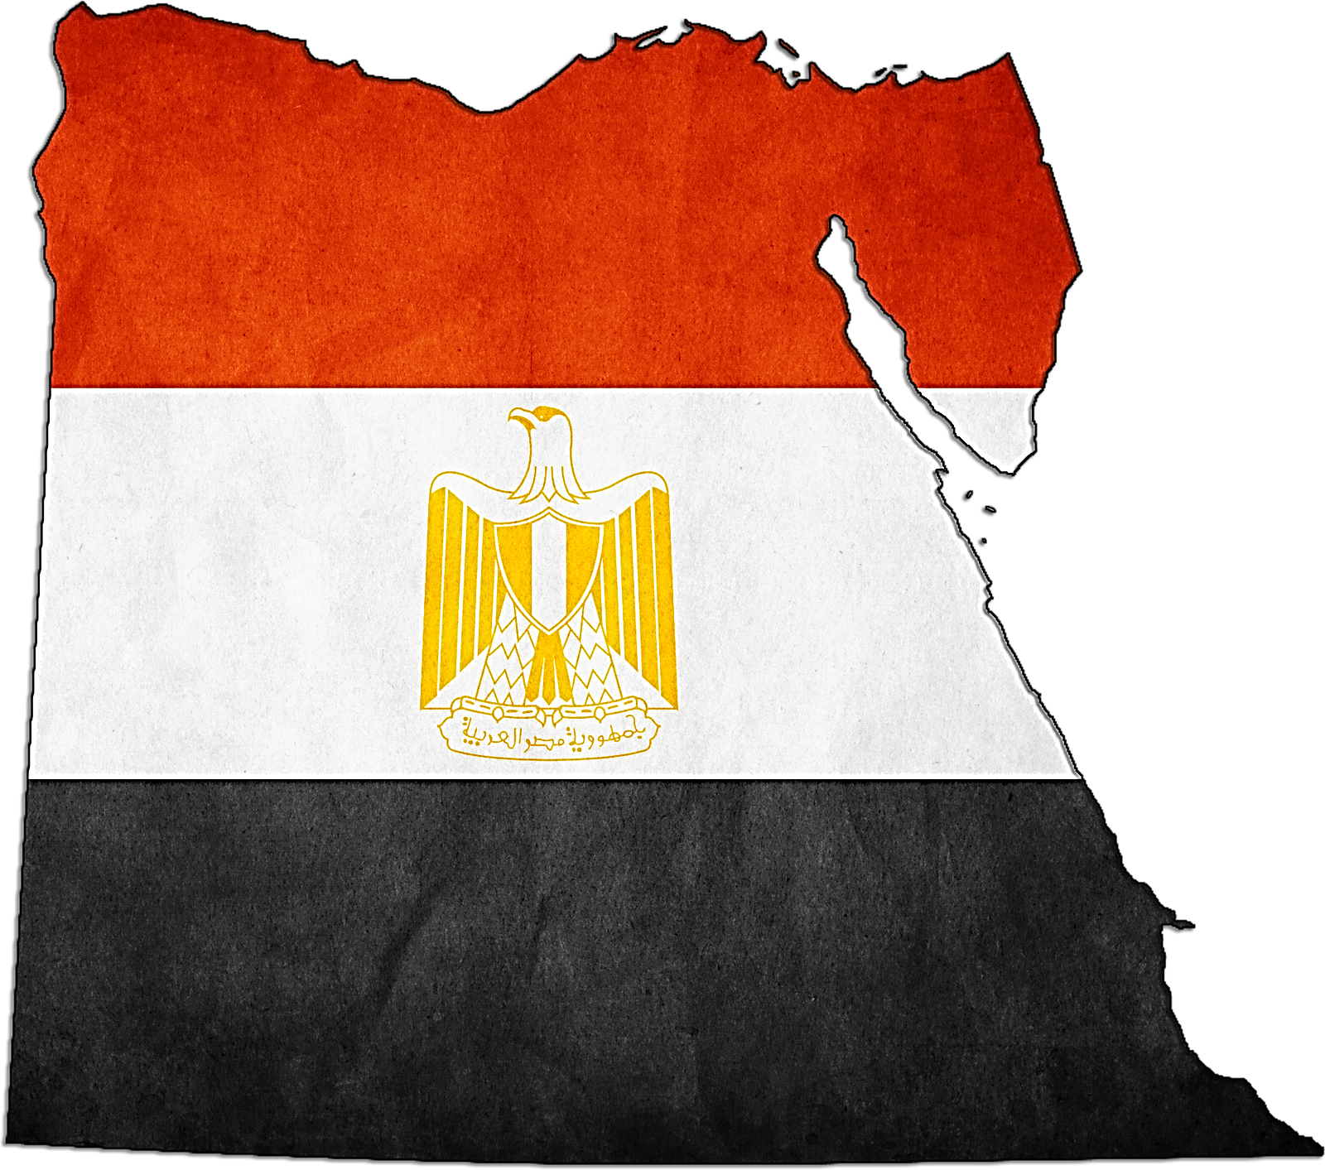
Egypt
Type of Exhaustion | Exceptions to Exhaustion
International | No known exceptions.
Assessment of Parallel Imports
Can Unauthorized Parallel Imports Be Prevented From Entering Country?
Given that the Egyptian local laws are subject to international exhaustion of rights, the brand owners do not have rights to prevent such entry of goods in the local markets.

Does Customs Support/Assist Trademark Owner With PI?
While the Customs law in Egypt has specific provisions to take action against counterfeits there is nothing specifically mentioned in the customs law for parallel imported goods.

Applicable Legislation
Intellectual Property Rights Law (Law No. 82/ 2002, Official Journal -ALWAKAA –AL MASREA, issue No. 22 bis, June 2, 2002, hereinafter ‘the IPR law’) was enacted and it came into force on June 4, 2002

What Procedures Are Available Once PI Enter Country?

None.

What Remedies Are Available?

The only remedy to secure exhaustion of IP rights in Egypt is by way of contractual obligations. The local courts usually consider the breach on restriction to export by a purchaser in the same manner as any other contractual obligation between the parties. Accordingly, the court passes order restraining unauthorized exports and/or imports and assesses damages for such breach (lost profits and damage sustained).

Key Case Law: To date, Egypt has not received any court decision on this issue.
Additional Comments
The introduction of International Exhaustion of IP rights in almost all the IPR sections in Egypt’s IPR law is a weakness of the present law, given that the producer of products which are protected by a bundle of IP rights cannot rely on the other IP rights to oppose the importation of a given product into Egypt. In an effort to combat parallel imports, the Egyptian law needs to either include the domestic or regional exhaustion rules. The other alternative could be the amendment of the international exhaustion doctrine to an extent so that it is restrictive. Nonetheless, one has to always consider that Egypt as a country has certain macro issues and weaknesses which delays or paralyses any new change from being implemented. Issues, such as, deficient enforcement of basic IPR regulations, cost and length of proceedings, and political uncertainty are a few of the major drawbacks of the legislative systems in Egypt.
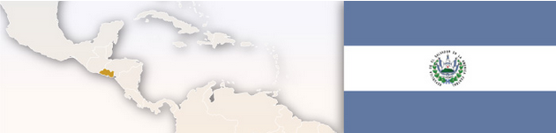


England and Wales
Type of Exhaustion | Exceptions to Exhaustion
Regional EU-wide (+ material differences element)
May object to product put first into circulation in the EEA without consent of the proprietor.
Internal EEA exhaustion may not apply where there are legitimate reasons to oppose further dealings in the goods. This may include where goods are impaired or changed; sometimes where they have been repackaged/relabelled where there is a risk of damage to reputation.
Assessment of Parallel Imports
Can Unauthorized Parallel Imports Be Prevented From Entering Country?

Yes, by initiating civil litigation seeking an injunction (whether only on a “final” or also on an “interim” basis). See below for details on possible customs action.
However, it is uncertain what Brexit will do with regard to PI’s.
Does Customs Support/Assist Trademark Owner With PI?
PI are not subject to control under EU Regulation 608/2013 but, in certain cases, may be restricted under domestic UK law. Under s. 89 of the UK Trade Marks Act 1994, the proprietor or licensee may issue a written notice to Her Majesty’s Revenue and Customs (“Customs”) alerting that goods are expected to arrive in the UK that will infringe a registered trade mark, and request that they be treated as prohibited goods (which will be seized and subject to forfeiture). The notice filed with Customs must be very detailed, providing the expected date and time of arrival. This is not a commonly used procedure because it is unusual for the trade mark owner to have the required information in advance.

What Procedures Are Available Once PI Enter Country?

Civil litigation may be commenced to prevent further dealings in PI’s - an injunction may be sought (whether only on a “final” or also on an “interim” basis) – see below for other remedies. In certain cases, criminal proceedings may be possible. For certain products, e.g. food or pharmaceuticals, from outside the EEA, regulatory enforcement authorities, UK Trading Standards, may assist if the products do not comply with local regulations.

What Remedies Are Available?

In civil litigation, the following remedies may be sought: injunction against committing acts of infringement including further dealings in the goods (whether only on a “final” or also on an “interim” basis, pending full trial); seizure/destruction of infringing goods; delivery up of infringing articles; damages or an account of profits (but not both); often information as to origin of goods; most judgments are publically available but an order for publicity of the outcome of the judgment is also available. For criminal acts, fines and imprisonment could be ordered but these provisions are directed principally at counterfeit products.
Key Case Law:
Oracle America Inc v M-Tech Data Limited [2012] UKSC 27

Applicable Legislation

Trade Marks Act 1994; "Free Movement of Goods" principle (Arts. 34-36 TFEU)
Additional Comments
An action for copyright infringement may be an alternative to trademark based actions in certain cases. In addition to potential civil litigation based on copyright, section 111 of the Copyright Designs and Patents Act 1988 provides that a copyright holder may file a notice with customs for intercepting infringing copies of printed literary, dramatic or musical works for goods entering the EEA from outside the EEA, or goods from within the EEA but not having been entered in free circulation.

Information obtained from Customs may not be used for purposes outside of the remit of Customs’ seizure authority. A separate court order for that information would be required to use that information for a civil action against PI, for example.


Finland
Type of Exhaustion | Exceptions to Exhaustion
Regional- EU wide
(+ material differences element)

May object to product put into circulation from outside the EEA without its consent. Exhaustion may not apply where there are legitimate reasons to oppose - including where goods are impaired or changed; sometimes where they have been repackaged/relabeled and where there is a risk of damage to reputation.
Assessment of Parallel Imports
Can Unauthorized Parallel Imports Be Prevented From Entering Country?
Civil litigation - injunction order; possibly criminal action under the Finnish Criminal Code for an intellectual property offence. There are also criminal sanctions under the Finnish Trademarks Act, but the injured party must wish to press charges.
Does Customs Support/Assist Trademark Owner With PI?
Additional Comments
While customs is supposed to seize only counterfeit products, if there is reason to suspect that a UPI shipment is imminent, customs may be alerted and information may be provided (the trademark, point of origin of goods, information on freight forwarders, grounds on which rights have been exhausted) - sometimes customs may act on information. Also, copyright based actions may be more effective depending on the case. Unfair competition may be used as an additional ground in an infringement case.

No - only for counterfeits under EU Anti-Piracy Regulation.

What Procedures Are Available Once PI Enter Country?

Civil litigation or criminal actions against an infringer.

What Remedies Are Available?

Seizure/destruction of infringing goods; order to cease and desist; damages/compensation; information concerning origin of goods; publication of judgment; fines and imprisonment; disclosure of information regarding sale of infringing goods to commercial recipients and their identities.

Key Case Law: In a Finnish supreme court case, company B had parallel imported products of company A which were repacked and marked with trademarks of A and B. The Supreme Court held that there was a likelihood of confusion regarding the commercial origin of the products and therefore A had the right to forbid use of its mark.


France
Type of Exhaustion | Exceptions to Exhaustion
Regional- EU wide  (+ material differences element) | The owner recovers its right to oppose the commercialization of the goods if he demonstrates a legitimate reason, for example if the goods have been changed or impaired after they have been put on the market.
Assessment of Parallel Imports
Can Unauthorized Parallel Imports Be Prevented From Entering Country?
Yes, by initiating a civil litigation, which can take form of summary proceedings or of ex parte basis (article L. 716-6 of the French Intellectual Property Code), being understood that the claimant must prove that its rights are infringed or that such infringement is imminent.

Does Customs Support/Assist Trademark Owner With PI?
No. It is excluded by the sixth recital of the Regulation n° 608/2013 and the French customs focus on the counterfeit products.

What Procedures Are Available Once PI Enter Country?

- Civil litigation for trademark infringement on the merits, including a claim for preliminary injunction;
- Criminal proceedings;
- Cease and desist letter to the importer in order to obtain the withdrawal the goods from the French market.
Applicable Legislation
Article L.713-4 of the French Intellectual Property Code

What Remedies Are Available?

- Seizure and destruction of the goods;
- Damages;
- Information upon request of the trademark owner, the Court may order the importer to disclose all information related to the origin of the goods and the distribution network;
- Publication of the judgement;
- Fines and more rarely incarceration.

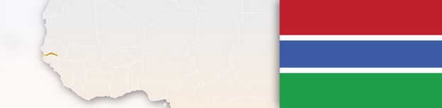

Gambia
Type of Exhaustion | Exceptions to Exhaustion
International
Assessment of Parallel Imports
Can Unauthorized Parallel Imports Be Prevented From Entering Country?
There seems no prevention offered in local Gambian laws as the country follows international exhaustion.
Does Customs Support/Assist Trademark Owner With PI?
Customs would not be able to provide any logical support as legally there are no restrictions imposed.

What Procedures Are Available Once PI Enter Country?

PI’s are usually not restricted and hence are freely sold in local markets.
What Remedies Are Available?

The local distributor can seek some redress from the authorities responsible for weights and measures and standardization of products.

Germany
Type of Exhaustion | Exceptions to Exhaustion
Regional EU-Wide (+ material differences element)

May object to product put into circulation from outside the EEA without consent. Exhaustion may not apply where there are legitimate reasons to oppose - including where goods are impaired or changed.

Assessment of Parallel Imports
Can Unauthorized Parallel Imports Be Prevented From Entering Country?
Customs, civil litigation and criminal proceedings.

Does Customs Support/Assist Trademark Owner With PI?
An application may be made according to the national provisions. Note that the more details provided to customs, the better chance that customs will identify the infringing goods.

Applicable Legislation
Sec. 24 para 1 of German Trademark Act.
What Procedures Are Available Once PI Enter Country?

Civil litigation and criminal action.

What Remedies Are Available?

Seizure/destruction of goods and devices; order to cease and desist; damages; information as to origin of goods and distribution network; publication of the judgment; fines and imprisonment; cost reimbursement. On the other hand, an importer may claim damages in the case of an unjustified seizure by customs.

Key Case Law: An importer may claim damages in the case of an unjustified seizure by customs. There may also be claims based on unfair competition in case of breach of a selective distribution system.
Additional Comments
There may also be claims based on unfair competition in case of breach of a selective distribution system.

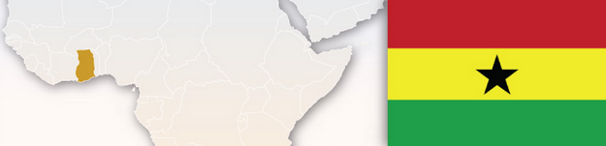

Ghana
Type of Exhaustion | Exceptions to Exhaustion
International
Assessment of Parallel Imports
Can Unauthorized Parallel Imports Be Prevented From Entering Country?
There seems no prevention offered in local Gambian laws as the country follows international exhaustion.
Does Customs Support/Assist Trademark Owner With PI?
Customs would not be able to provide any logical support as legally there are no restrictions imposed.

What Procedures Are Available Once PI Enter Country?

PI’s are usually not restricted and hence are freely sold in local markets.

What Remedies Are Available?

The local distributor can seek some redress from the authorities responsible for weights and measures and standardization of products.

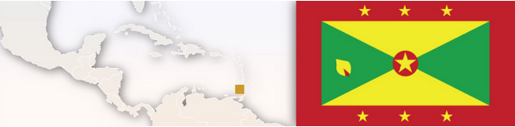

Grenada
Type of Exhaustion | Exceptions to Exhaustion
International (question: is Grenada member of CARICOM and should there therefore be regional exhaustion?) | No
Assessment of Parallel Imports
Can Unauthorized Parallel Imports Be Prevented From Entering Country?
No.
Does Customs Support/Assist Trademark Owner With PI?
No.

What Procedures Are Available Once PI Enter Country?

None.
What Remedies Are Available?

None.



Greece
Type of Exhaustion | Exceptions to Exhaustion
Regional EU-wide (+ material differences element)

May object to product put into circulation from outside the EEA without consent. Exhaustion may not apply where there are legitimate reasons to oppose - including where goods are impaired or changed. Also when the importer commits acts considered to be unfair competition under local legislation (when importers create the impression they are members of the IP holder's distribution network or the importers attempt to convince members of the owner's distribution network to breach their contract with the IP owner).
Assessment of Parallel Imports
Can Unauthorized Parallel Imports Be Prevented From Entering Country?
Customs; civil litigation; and criminal proceedings.

Does Customs Support/Assist Trademark Owner With PI?
Yes - you can apply for customs action with information such as IP rights, information regarding the product and packaging, distribution network, ways to distinguish between goods.

What Procedures Are Available Once PI Enter Country?

Civil litigation; criminal proceedings.

What Remedies Are Available?

Seizure/destruction of goods; order to cease and desist; damages; often information as to origin of goods and distribution network; publication of the judgment; fines and imprisonment.
Applicable Legislation
Trademarks Act 4072/2012, article 128

Guatemala
Type of Exhaustion | Exceptions to Exhaustion
International | When the goods have been altered, modified or deteriorated.
Assessment of Parallel Imports

Can Unauthorized Parallel Imports Be Prevented From Entering Country?
No, unless the goods or packaging have been altered modified or deteriorated.

Applicable Legislation
Decree 57-2000
Does Customs Support/Assist Trademark Owner With PI?
No. It may be possible if proven that the goods have been altered, modified or deteriorated, Also if it can be shown that importation is not by consent or some economic tie to proprietor.

What Procedures Are Available Once PI Enter Country?

None.

What Remedies Are Available?

None.

Additional Comments
The case law in this area has not yet developed. The pervading approach is that parallel imports cannot be denied importation for any reason, except where the good have been altered, modified or deteriorated. Little attention is paid to the "consent" requirement or the "economic vinculation" test, a pre requisite to be held as an authorized parallel import. Currently the “material differences’ test is not applied.

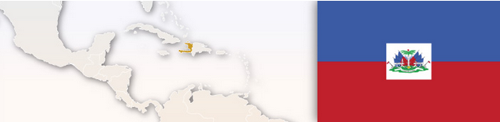

Haiti
Assessment of Parallel Imports
Type of Exhaustion | Exceptions to Exhaustion
International (question: Haiti is CARICOM member so should be regional?) | No.
Can Unauthorized Parallel Imports Be Prevented From Entering Country?
No.
Does Customs Support/Assist Trademark Owner With PI?
No.

What Procedures Are Available Once PI Enter Country?

No.

What Remedies Are Available?

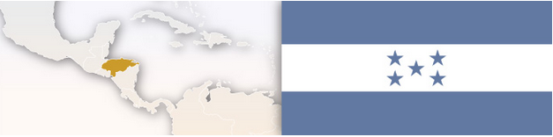
None.

Honduras
Type of Exhaustion | Exceptions to Exhaustion
International. | Exceptions to parallel imports may exist where contractual agreements between parties state otherwise, though exclusive distribution is not permitted amongst members of Dominican Republic-Central America Free Trade Agreement.
Assessment of Parallel Imports
Can Unauthorized Parallel Imports Be Prevented From Entering Country?
No.

Does Customs Support/Assist Trademark Owner With PI?
None.

What Procedures Are Available Once PI Enter Country?

None.
What Remedies Are Available?

None.

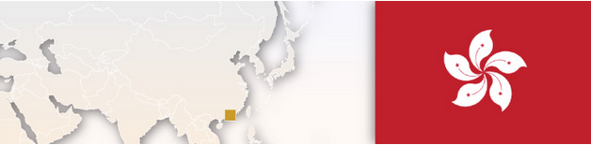

Hong Kong
Type of Exhaustion | Exceptions to Exhaustion
International | If the condition of the goods has been changed or impaired after they have been put on the market, and the use of the registered trade mark in relation to those goods is detrimental to the distinctive character or repute of the trade mark.
Assessment of Parallel Imports
Can Unauthorized Parallel Imports Be Prevented From Entering Country?
In Hong Kong, use of a registered trade mark in relation to goods which have been put on the market anywhere in the world under that trade mark by the owner or with the owner's consent (whether express or implied or conditional or unconditional) does not constitute infringement. Thus genuine goods cannot be prevented from entering the country. Having said that, the same is not allowed where the condition of the parallel imported goods has been changed or impaired after they have been put on the market, and the use of the registered trade mark in relation to those goods is detrimental to the distinctive character or repute of the trade mark [Section 20(2) of the Trade Marks Ordinance (TMO)].
Does Customs Support/Assist Trademark Owner With PI?
Applicable Legislation
Trade Marks Ordinance (Chapter 559)
Customs will detain/seize PI’s (unauthorized parallel imports ) if they suspect it to be counterfeit and if they are identified by the trade mark owners as counterfeit or not genuine parallel imports.

What Procedures Are Available Once PI Enter Country?

If the condition of the parallel imported goods are changed or impaired, customs assistance can be sought under the Trade Descriptions Ordinance (TDO) which includes criminal liability as well. Alternatively, civil action under the (TMO) is available.

What Remedies Are Available?

Under the TDO, a person who applies a false trade description to the parallel imported goods is liable to fines and potential imprisonment. This may include false representation that the goods supplied are imported through official dealers or provided with after-sale and maintenance services.

TMO - A parallel importer may also be liable for passing off by making false claims of association with or connection to the original brand owner and/or false claims that the parallel imported goods are of comparable quality as particular goods supplied by the brand owner. See for example: Pringle of Scotland Limited v Fung Yun Fong, Gloria HCA 236/2005 (2005) HKEC 1145 (for interlocutory injunction) and (2005) HKEC 1872 (for summary judgment). Under the TMO, remedies include injunctions, delivery of infringing goods, and disclosure of dealings in the goods, damages and legal costs.

Hungary
Assessment of Parallel Imports
Can Unauthorized Parallel Imports Be Prevented From Entering Country?
Civil litigation or criminal action.


Does Customs Support/Assist Trademark Owner With PI?
No.

What Procedures Are Available Once PI Enter Country?

Civil litigation, criminal proceedings.
Applicable Legislation
Article 16(1) of Act No. XI of 1997

What Remedies Are Available?

Seizure/destruction of goods and devices; order to cease and desist; damages; information as to origin of goods and distribution network; publication of the judgment; fines and imprisonment; cost reimbursement.

Additional Comments
Customs may be lectured about infringing products.

Type of Exhaustion | Exceptions to Exhaustion
Regional EU-wide (+ material differences element) | May object to product put into circulation from outside the EEA without consent. Exhaustion may not apply where there are legitimate reasons to oppose - including where goods are impaired or changed.

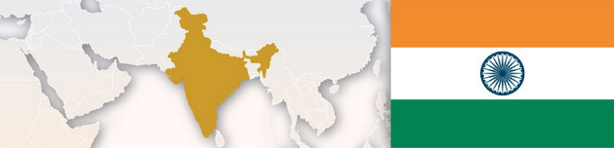

India
Type of Exhaustion | Exceptions to Exhaustion
International

1. Unlawful acquisition of the goods from the market. 2. The registered trademark owner has legitimate reasons to oppose further dealings in the goods, especially where the condition of the goods has been changed or impaired after they have been put on the market. Other reasons may include violation of packaging and regulatory laws of India, misrepresentation, and so on.
Assessment of Parallel Imports
Can Unauthorized Parallel Imports Be Prevented From Entering Country?
No.
Does Customs Support/Assist Trademark Owner With PI?
Applicable Legislation
Trade Marks Act, 1999
Designs Act, 2000
Intellectual Property Rights (Imported Goods) Enforcement Rules, 2007 under the Customs Act, 1962.
No. As per the prevalent notification issued by the Customs for the purposes of detention/seizure for border enforcement, parallel import is not prohibited under the trade marks and patent law; however the design law does not allow parallel imports.

What Procedures Are Available Once PI Enter Country?

Civil Litigation.
What Remedies Are Available?

A lawsuit may be filed by trademark owner for injunction, seizure/delivery-up /destruction of offending goods, damages or account for profit. Interim reliefs including injunction, civil raid and preservation/seizure of offending goods, discovery, may also be granted.
Additional Comments
As of now, Indian law recognizes international exhaustion and does not prohibit parallel imports per se, unless such goods unlawfully acquired and/or have been altered or not in compliance with Indian regulatory or legal requirements etc. As regards the aspect of manufacturer's warranty not being available in case of such parallel imports, the suppliers/sellers/dealers are liable to prominently display the disclaimer that the goods sold by parallel importers are imported into India and the manufacturer/trade mark owner does not warranty the quality of the goods nor provides any after-sales service for the goods.
However, the issue whether India follows national or international exhaustion is presently under appeal before the Supreme Court of India by Samsung and is pending final decision.

Israel
Assessment of Parallel Imports
Can Unauthorized Parallel imports Be Prevented From Entering Country?
No. Israeli courts have held that unauthorized parallel importing is permitted in Israel.
Does Customs Support/Assist Trademark Owner With PI?
No.
What Procedures Are Available Once PI Enter Country?
N/A. Trademark infringement actions are possible in case the product (or its packaging) has undergone a change, alteration, or deterioration.
What Remedies Are Available?
N/A. In case of trademark infringement actions as described above: Seizure/destruction of the infringing goods; injunctive order; damages.
Type of Exhaustion:
International. (+ material differences element)
Exceptions to exhaustion:
Possible in case the product (or its packaging) has undergone a change, alteration, or deterioration.
Applicable legislation:
N/A.

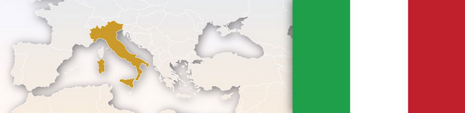

Italy
Type of Exhaustion | Exceptions to Exhaustion
Regional EU-wide (+ material differences element) | May object to product  put into circulation  from outside the EEA  without its consent.  Exhaustion may not  apply where there are  legitimate reasons to  oppose – including  where goods are  impaired or changed.  Repackaging and/or  labeling is one of the  cases where the  owner may have a  legitimate reason to  prevent an otherwise  authorized parallel  import.
Assessment of Parallel Imports
Can Unauthorized Parallel Imports Be Prevented From Entering Country?
Civil Litigation.
Does Customs Support/Assist Trademark Owner With PI?
Despite (UE) 2015/2424 of 16 December 2015, at whereas 16, says it should be permissible for EU trade mark proprietors to prevent the entry of infringing goods and their placement in all customs situations, including transit, transshipment, warehousing, free zones, temporary storage, inward processing or temporary admission, also when such goods are not intended to be placed on the market of the Union, intervention by the Custom Authorities appears to be currently limited to cases of counterfeit of IP right, and in case of parallel import the Custom Authorities release the goods, thus leaving to the owner of the IP right the onus of protecting it through a civil action.

What Procedures Are Available Once PI Enter Country?

Standard civil actions and interim injunction
According to some authors, since 2009 also criminal actions according to Art. 571ter of the Italian Criminal Code would be possible.

Applicable Legislation
Industrial Property Code - Legislative Decree No. 30 of 10 February 2005

What Remedies Are Available?

As regards the standard actions, infringement decisions, unfair competition, destruction of goods, final injunction, publication of the judgement, recovery of damages, orders to disclose documents, or to inform about subjects involved in the manufacture and distribution of the infringing products or about the origin and the distribution networks of the infringing goods, refund of legal fees.
As regards injunction proceedings, mainly seizure and/or injunction orders, destruction of goods, publication orders, refund of legal fees.



Ireland
Type of Exhaustion | Exceptions to Exhaustion
Regional EU-wide (+ material differences element)
Where there are "legitimate reasons for the proprietor to oppose further dealings in the goods" (sect. 16 (1) of the Trade Marks Act). "Legitimate reasons" might include where the condition of the goods has been impaired or the goods have otherwise been changed; where the goods have been re-packaged/re-labeled (subject to further exceptions); where there is risk that the trademark and/or trademark owner's reputation may be seriously damaged.
Assessment of Parallel Imports
Can Unauthorized Parallel Imports Be Prevented From Entering Country?
PI’s are not subject to control by Irish customs. An injunction may, in principal, be sought to prevent gray market goods. Once notified of a PI, proprietor could choose to send a cease and desist letter to the importer.

Does Customs Support/Assist Trademark Owner With PI?
No support by Customs with PI’s.

What Procedures Are Available Once PI Enter Country?

Civil litigation.

What Remedies Are Available?

A rights holder could seek an injunction preventing the further sale of the goods. Potentially also seek any of the other remedies typically associated with the trademark infringement such as an account of profits, delivery up of the goods etc. Possibility also to send a cease and desist letter requesting signed undertakings to destroy goods and not to import further infringing goods.

Applicable Legislation
Trade Marks Act 1996 and the Directive 2008/95/EC

Jamaica
Type of Exhaustion | Exceptions to Exhaustion
International | No.
Assessment of Parallel Imports
Can Unauthorized Parallel Imports Be Prevented From Entering Country?
No.
Does Customs Support/Assist Trademark Owner With PI?
No.

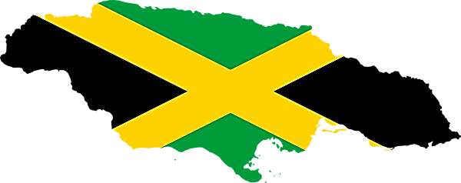
What Procedures Are Available Once PI Enter Country?

No.
What Remedies Are Available?

None.

Applicable Legislation
Japanese Trademark Law
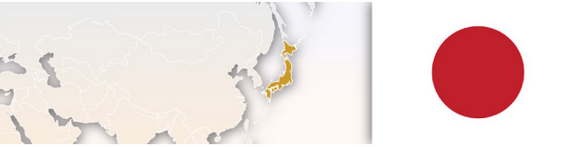

Japan
Type of Exhaustion | Exceptions to Exhaustion
International

Assessment of Parallel Imports
Can Unauthorized Parallel Imports Be Prevented From Entering Country?
If the import goods are not deemed parallel imports according to the requirements, they constitute trademark infringement.
Importation of products satisfying the following requirements will be deemed parallel imports and will not constitute trademark infringement.
1)The trademark on the parallel import goods was duly affixed thereto by the trademark owner in the exporting country or a licensee thereof;
2) The trademark owners in the exporting country and in Japan are the same party, or may legally or financially be deemed to be the same party, such that the trademark on the parallel import goods is deemed to indicate the same origin of goods as the origin indicated by the registered trademark in Japan (i.e., no damage on the origin indication function of the trademark); and
3) The parallel import goods and products bearing the registered trademark affixed by the trademark owner in Japan are not deemed to substantially differ in the quality guaranteed by the trademark (i.e., no damage on the product quality guarantee function of the trademark).
Does Customs Support/Assist Trademark Owner With PI?
No.

What Procedures Are Available Once PI Enter Country?

At customs; civil litigation; criminal action.

What Remedies Are Available?

None.

Key Case Law: Supreme Court Decision (Fred Perry Case).
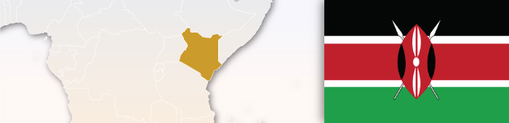

Kenya
Type of Exhaustion | Exceptions to Exhaustion
International
Assessment of Parallel Imports
Can Unauthorized Parallel Imports Be Prevented From Entering Country?
There seems no prevention offered in local Kenyan laws as the country follows international exhaustion.
Does Customs Support/Assist Trademark Owner With PI?
Customs would not be able to provide any logical support as legally there are no restrictions imposed.

What Procedures Are Available Once PI Enter Country?

PI’s usually are not restricted and hence are sold freely in local markets.
What Remedies Are Available?

The local distributor can seek some redress from the authorities responsible for weights and measures and standardization of products.

Kuwait
Assessment of Parallel Imports
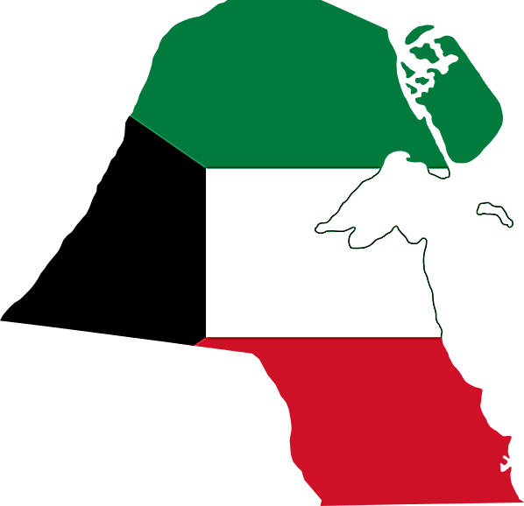
Can Unauthorized Parallel Imports Be Prevented From Entering Country?
Type of Exhaustion | Exceptions to Exhaustion
International
Only exceptions may be in the case of already restricted or prohibited goods and essential goods.
Applicable Legislation
Kuwaiti Trade Law 68 of 1980.
Given that the Kuwaiti local laws are subject to international exhaustion of rights, the brand owners do not have rights to prevent such entry of goods in the local market. However, as a part of a contractual obligation with specific clauses being mentioned in exclusive agency agreements, exclusive agents might restrain import of goods in the country by a third party. Further the trade law consists of restrictive provisions of the volume, quantity, and various trade indications to be mentioned in the goods that are being imported and sold in the local market, however, each of these restrictions are supported by a disclaimer to waive off these restrictions by way of a statement/declaration for the Ministry that would nullify such restrictions.
Additional Comments
The law is still developing in this jurisdiction and it will be a matter of time for the country to align its imports regulations or agency laws to restrict the incoming of parallel imported goods. Moreover, they also need to strictly implement the law that is presently available so that parallel imports may be restrained with the aid of prevalent commercial law provisions.

Does Customs Support/Assist Trademark Owner With PI?
Since there is no specific law to restrain parallel imports, the applicable restrictions under the trade indications and volumes and measures may be applied and customs' assistance could be sought. However, we are yet to experience these issues in this jurisdiction.

What Procedures Are Available Once PI Enter Country?

None.
What Remedies Are Available?

The only remedy to prevent exhaustion of IP rights in Kuwait is by way of contractual obligations. The local courts usually consider the breach on restriction to export by a purchaser in the same manner as any other contractual obligation between the parties. Accordingly, the court passes order restraining unauthorized exports and/or imports and assesses damages for such breach (loss of profit the and damage sustained).

Key Case Law: No cases found. Be that as it may, the onus of proof about the origin of the goods in the case of exhaustion of rights would lie on the claimant.


Lebanon
Assessment of Parallel Imports
Type of Exhaustion | Exceptions to Exhaustion
International

Only exceptions may be in the case of already restricted or prohibited goods and essential goods, i.e., the goods are not authorized by the trademark owner (or relevant licensee).

Can Unauthorized Parallel Imports Be Prevented From Entering Country?
Given that the Lebanese local laws are subject to international exhaustion of rights, the brand owners do not have rights to prevent such entry of goods in the local markets. However, as a part of a contractual obligation with specific clauses being mentioned in exclusive agency agreements, exclusive agents might restrain the import of goods in the country by a third party. Further the trademark law also stipulates the court’s power to restrain unfair competition. In view of these provisions, parallel imports may be restrained on the basis of commercial laws.

Does Customs Support/Assist Trademark Owner With PI?

While the Customs law in Lebanon has specific provisions to take action against counterfeits and against prohibited/restricted goods, there is nothing specifically mentioned in the customs law for parallel imported goods.

What Procedures Are Available Once PI Enter Country?

Due to lack of national exhaustion, once the parallel import enters there is no specific process that is followed. However, by way of contractual obligation, the exclusive distributor or agent may restrain through a full-fledged civil suit. It may also use provisions of Commercial Representation/agency laws which support rights provided to them. This may be further bolstered with grounds under unfair competition.

What Remedies Are Available?

Due to lack of national exhaustion, once the parallel import enters there is no specific process that is followed. However, by way of contractual obligation, the exclusive distributor or agent can restrain distribution through a full-fledged civil suit. It may also use provisions of Commercial Representation/agency laws which support rights provided to them. This may be further bolstered with grounds under unfair competition.

Additional Comments
It is worth mentioning that parallel import is legally recognized for certain essential basic goods like, medicine. Decision No. 539 dated 08/25/1998, allows companies other than official agents to bring medicines into Lebanon on a condition that the invoice is lower than the export registered price by 25 percent.
Applicable Legislation
Resolution No.2385/1924 issued on January 17, 1924, amended by the and Decree-Law No. 34 of August 5, 1967



Lithuania
Type of Exhaustion | Exceptions to Exhaustion
Regional EU-wide (+ material differences element) | If the goods have been marked and put by the proprietor of the mark or with his consent on the European Community market (Law on Trade Marks, Art. 40)
Assessment of Parallel Imports
Can Unauthorized Parallel Imports Be Prevented From Entering Country?
Civil litigation.
Does Customs Support/Assist Trademark Owner With PI?
No.

What Procedures Are Available Once PI Enter Country?
Applicable Legislation
Lithuanian Trademark Law

Civil Litigation.
What Remedies Are Available?

Additional Comments
Section 28(3) refers to international exhaustion. No precedent on parallel imports.
Seizure/destruction of the infringing goods; order to cease and desist; claims for damages/compensation/information concerning the origin of the goods; publication of the judgment.


Luxembourg
Type of Exhaustion | Exceptions to Exhaustion
Regional EU-wide (+ material differences element)

The principle of Community exhaustion is limited to cases where goods have been put on the market in the EEA by the trademark proprietor or with his consent. Thus, it does not apply when the proprietor markets its goods outside that area. By making it clear that the placement of goods on the market outside the EEA does not exhaust the trademark proprietor's right to oppose the importation (into the EEA) of the trademarked goods without its consent, the Community legislature allows trademark proprietors to control the initial marketing in the EEA of goods bearing their marks. Article 13(2) CTMR and Article 7(2) of Harmonization Directive 2008/95 cite as examples of legitimate reasons situations in which the condition of the goods has been changed or impaired. The expression "condition of the goods" should be interpreted broadly to refer not only to the goods themselves but also to their packaging.
Assessment of Parallel Imports
Can Unauthorized Parallel Imports Be Prevented From Entering Country?
Civil proceedings, i.e., summary proceeding – injunction from the President of the court in order to take measure to prevent any imminent infringement of an IP right.
Does Customs Support/Assist Trademark Owner With PI?
No.

What Procedures Are Available Once PI Enter Country?

Civil litigation.
What Remedies Are Available?

Seizure/destruction of goods; delivery of infringing articles; order to cease and desist including interim and final injunctions; damages or an account of profits; often information as to origin of goods; judgments are publically available; in certain cases imprisonment of up to three years.



Macedonia
Type of Exhaustion | Exceptions to Exhaustion
National

Assessment of Parallel Imports
Can Unauthorized Parallel Imports Be Prevented From Entering Country?
Civil litigation - a request for prohibition of future infringements and court injunctions.

Applicable Legislation
Article 209 - The Macedonian Industrial Property Law
Does Customs Support/Assist Trademark Owner With PI?
No.

What Procedures Are Available Once PI Enter Country?

Civil litigation - infringement action under Article 291; Article 12 of the Law Against Unfair Competition; civil action on the basis of breach of contractual obligations if applicable between the trademark holder and the parallel importer; possibly criminal under article 285 of the Macedonian Criminal Code if rights holder files a criminal complaint for suffering a criminal offence with the police or the Office of the State Prosecutor; in certain cases breach of competition law in accordance with the Competition Protection Act.

What Remedies Are Available?

Seizure/destruction of goods; delivery of infringing articles; order to cease and desist including interim and final injunctions; damages or an account of profits but not both; often information as to origin of goods; judgments are publically available; in certain cases imprisonment of up to three years; fines for unfair competition; possible civil penalty of 200% if intent or negligence to infringe is found.

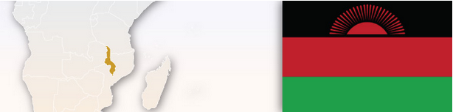
Malaysia
Type of Exhaustion | Exceptions to Exhaustion
International YES

Assessment of Parallel Imports
Can Unauthorized Parallel Imports Be Prevented From Entering Country?
Yes, if it falls under the exceptions to exhaustion.
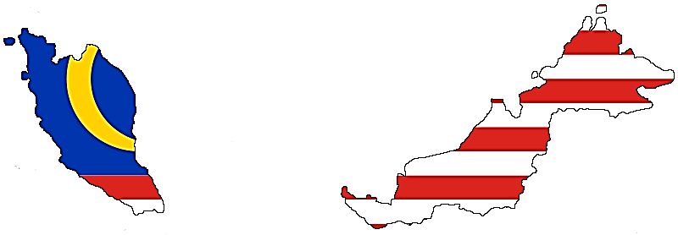
According to the Copyright Act 1987, the exclusive right to control the distribution of copies refer only to the act of putting into circulation copies not previously put into circulation in Malaysia and not to any subsequent distribution of those copies or any subsequent importation of those copies into Malaysia. According to the Trade Marks Act 1976 and case laws in Malaysia, the exceptions are as follows: a) There is nothing on the pack to suggest that there are territorial restrictions in respect of the sale of the products. b) There was nothing on the packs or boxes that purported to restrict the exportation of the product. c) There was no evidence that the sales of the product were made conditional and inference to be drawn is that they were not. d) There were no contractual restrictions imposed on the licensee.
Does Customs Support/Assist Trademark Owner With PI?
Unlikely without a Court Order.

What Procedures Are Available Once PI Enter Country?

Civil Litigation.

What Remedies Are Available?

Civil remedies that are available are declaration of infringement, delivery up, injunction, damages and costs.
Applicable Legislation
Section 13 (1) of Copyright Act 1987 & sections 40(1)(d) and 40(1)(dd) of the Trade Marks Act 1976

Key Case Law:
1. Trade Marks Act 1976;
2. Copyright Act 1987;
3. Winthrop Products Inc & Anor v Sun Ocean (M) Sdn Bhd & Anor [1988] 1 LNS 21;
4. Tien Ying Hong Enterprise Sdn Bhd v Beenion Sdn Bhd [2011] 2 CLJ 469



Malta
Type of Exhaustion | Exceptions to Exhaustion
Regional EU-wide (+ material differences element) | May object to product put into circulation from outside the EEA without its consent. Exhaustion may not apply where there are legitimate reasons to oppose - including where goods are impaired or changed.
Assessment of Parallel Imports
Can Unauthorized Parallel Imports Be Prevented From Entering Country?
PI might theoretically be subjected to customs controls by virtue of an application of provisions contained in EC Regulation No. 608/2013 as well as the Intellectual Property (Cross Border Measures) Act (Cap. 414 Laws of Malta). In practice however, Maltese customs authorities do not consider PI as counterfeit goods and on that basis, they do not detain such goods as a matter of policy. This policy is not cast in stone and may be tested from time to time in given circumstances which may arise.

Applicable Legislation
Art 12(10 Trademarks Act 2000
Does Customs Support/Assist Trademark Owner With PI?
Refer to previous answer.

What Procedures Are Available Once PI Enter Country?

Trademark infringement action in terms of relevant provisions contained in article 10 TMA (unauthorized use of an identical trademark in the course of trade). In this context, see judgment of the First Hall of the Civil Court in re Dr. Luigi A. Sansone noe. vs R.B. Trading Ltd (840/2007GC). There are no specific provisions of law which appear to have been evoked with respect to PI, although there are provisions of law contained in the Criminal Code (Cap. 9 Laws of Malta) which might possibly be evoked in a given test case.

What Remedies Are Available?

Seizure/destruction of goods; delivery of infringing articles; order to cease and desist including interim and final injunctions; damages or an account of profits but not both; often information as to origin of goods; judgments are publically available; in certain cases imprisonment.



Mauritius
Type of Exhaustion | Exceptions to Exhaustion
National | If first sale was unlawful.
Assessment of Parallel Imports
Can Unauthorized Parallel Imports Be Prevented From Entering Country?
Yes. The Trade Mark Law in Mauritius allows a trade mark owner to take action against genuine goods which have been placed in the market in Mauritius without the trade mark owner’s consent.
Applicable Legislation
Copyright Act
Does Customs Support/Assist Trademark Owner With PI?
Yes, but only to the extent that the goods will be stopped if a Customs watch has been put in place.

What Procedures Are Available Once PI Enter Country?

Additional Comments
In terms of the Copyright Act, no action can be taken against parallel imports based on copyright unless the first distribution was unlawful. In practice, it is likely that the first distribution will always emanate from the copyright owner.
Once PI have entered the country, administrative authority would not act on the same. The trade mark owner has to apply for an injunction and civil seizure before the Court. The Customs or police officials will not offer assistance.
What Remedies Are Available?

As mentioned in the procedures above, the only remedy for a trade mark owner is to apply to a Court for a seizure order of the products to declare them PI’s and either have them destroyed or re-exported.

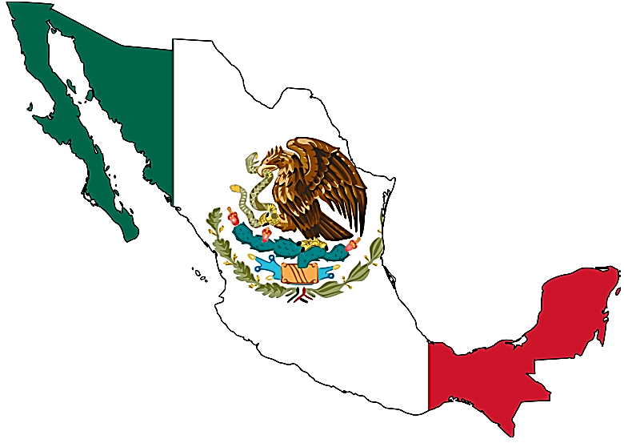
Mexico
Type of Exhaustion | Exceptions to Exhaustion
International | YES.
Assessment of Parallel Imports
Can Unauthorized Parallel Imports Be Prevented From Entering Country?
No. Under the trademark laws, there is international exhaustion of rights. Once the source of the products is authentic, there is no trademark infringement.
In specific cases, where there is a risk of personal injury (E.g.- defective products), a health hazard (e.g.- expired products) or diverted products specifically formulated for a certain jurisdiction, that will not work in a different jurisdiction (e.g.- detergents formulated to work with specific water pH levels), it is possible to seek intervention of other authorities such as Health and Consumer Protection.
Does Customs Support/Assist Trademark Owner With PI?
No. Customs authorities may only stop importation of non-restricted goods if an Administrative or Judicial order is issued to stop importation. On a case by case basis, there may be other issues to be explored to determine if there are any grounds for the grant of such an order

What Procedures Are Available Once PI Enter Country?
None. However, other administrative or judicial procedures may be explored on a case by case basis in case the imported goods violate other administrative laws in the country (E.g.- Health Laws, Consumer protection Laws, etc.).
What Remedies Are Available?

None. In particular cases that would need to be assessed individually, if material or moral damage may be proven to have arisen as a direct result of a legal or civil wrongdoing (damage for which may be difficult to prove), including breach of contract, then it is possible to seek monetary compensation or remedy before a civil judge.

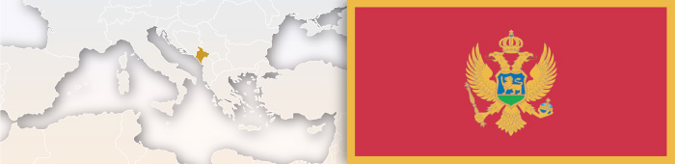

Montenegro
Type of Exhaustion | Exceptions to Exhaustion
International | If there is no consent and rights holder has a legitimate reason for opposing commercialization - if a defect or other fundamental change of condition.
Assessment of Parallel Imports
Can Unauthorized Parallel Imports Be Prevented From Entering Country?
No.
Does Customs Support/Assist Trademark Owner With PI?
No.

What Procedures Are Available Once PI Enter Country?

Civil litigation - lawsuit for trademark infringement under Article 55 of the Trademarks Act; criminal action under Article 271; possibly UPI could be a case of unfair competition under article 39 of the Law on internal trade (in which case there are penal provisions of 7500 to 45000 EUR).

What Remedies Are Available?

Seizure/destruction of goods; delivery of infringing articles; order to cease and desist including interim and final injunctions; damages or an account of profits but not both; often information as to origin of goods; judgments are publically available; in certain cases imprisonment.

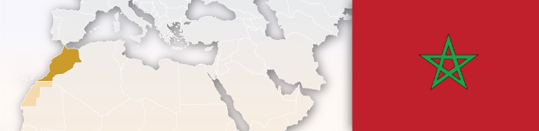

Morocco
Type of Exhaustion | Exceptions to Exhaustion
Unclear
Strong clauses in the competition law and agency law empower the authorized dealers to appeal against parallel importers and implement national exhaustion in the country.
Assessment of Parallel Imports
Can Unauthorized Parallel Imports Be Prevented From Entering Country?
Applicable Legislation
(1) Law of free pricing and competition (Law No. 06-99) - Article 6 and 7
(2) Agency Law
Exclusive agent may have powers to restrain any parallel importation of goods into the Moroccan market by recording the trademark/brand (registered in the name of the brand owner at the TMO) with the customs office. Customs under such circumstances, would restrain any goods to enter into the market that were being imported by any third party other than the exclusive agent. However, an exception to this applies to pharmaceuticals and a few other goods of basic necessity which are exempted from this and parallel imports for these goods would be permitted.

Does Customs Support/Assist Trademark Owner With PI?
Yes.

What Procedures Are Available Once PI Enter Country?

None.
What Remedies Are Available?

Law on free pricing and competition (Law No. 06-99) Article 6: Under certain specific provisions of this law a business entity may be prohibited from engaging in unfair competition when they tend to: 1 - Hinder the formation of prices by market forces by artificially favoring price increases or decreases; 2 – Limit or control production, markets, investment or technical progress; Article 7: Is prohibited when the purpose or may have the effect of preventing, restricting or distorting the competition, abuse by a company or group of companies: Abuse may also consist of price offers or sales price of predatory practices to consumers, compared to the costs of production, processing and marketing, since these offers or practices are intended, or may have the effect of eliminating a market, or prevent access to a market, a company or any of its products.

Myanmar
Type of Exhaustion | Exceptions to Exhaustion
Unclear
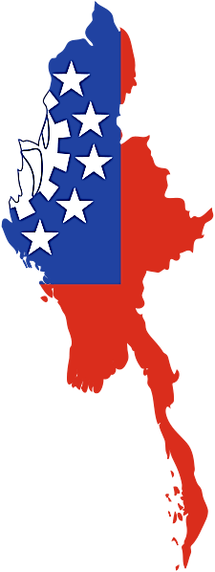
Assessment of Parallel Imports
Can Unauthorized Parallel Imports Be Prevented From Entering Country?
Possible, through general law of passing off where there is a tangible possibility of damage to some business or trading activity or through the Specific Relief Act of 1877 which provides that when the defendant invades or threatens to invade the plaintiff's right to, or enjoyment of, property, the court may grant a perpetual injunction and/or compel the performance of certain acts.

Does Customs Support/Assist Trademark Owner With PI?

A holder of a copyright may give notice to the customs authorities to prevent the importation of unauthorized goods which would infringe a copyright for works done or copyrighted goods in Myanmar.
Applicable Legislation
Myanmar Copyright Act 1914
Myanmar Merchandise Marks Act 1889
Specific Relief Act
Burma Penal Code

What Procedures Are Available Once PI Enter Country?

Civil Litigation.

What Remedies Are Available?

Injunction, damages.

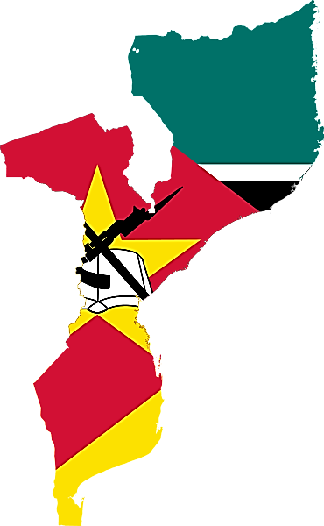
Mozambique
Type of Exhaustion | Exceptions to Exhaustion
International
Assessment of Parallel Imports
Can Unauthorized Parallel Imports Be Prevented From Entering Country?
There seems no prevention offered in local Algerian laws as the country follows international exhaustion.
Does Customs Support/Assist Trademark Owner With PI?
Customs would not be able to provide any logical support as legally there are no restrictions imposed.

What Procedures Are Available Once PI Enter Country?

PI usually are not restricted and hence are sold freely in local markets.

What Remedies Are Available?

The local distributor can seek some redress from the authorities responsible for weights and measures and standardization of products.

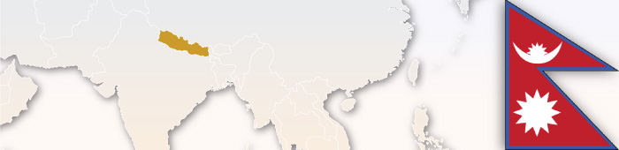

Nepal
Type of Exhaustion | Exceptions to Exhaustion
National
Assessment of Parallel Imports
Can Unauthorized Parallel Imports Be Prevented From Entering Country?
Applicable Legislation
The Patent, Design and Trade Mark Act, 2022 (1965)
Yes.
Does Customs Support/Assist Trademark Owner With PI?
Yes. A request can be made to the concerned Customs Officer for withholding the import of PI’s.
What Procedures Are Available Once PI Enter Country?
Additional Comments
No precedent on parallel imports.

Civil Litigation
What Remedies Are Available?

A suit may be filed by the Trademark owner for imposition of fine and confiscation of the PI’s.

Netherlands
Type of Exhaustion | Exceptions to Exhaustion
Regional EU-wide  (+ material differences element) | If there is no consent and the trademark owner has a reasonable justification for opposing the sale of the goods, i.e., if goods/packaging are altered or deteriorated.
Assessment of Parallel Imports
Can Unauthorized Parallel Imports Be Prevented From Entering Country?
No.
Does Customs Support/Assist Trademark Owner With PI?
No, only counterfeit. If PI goods are seized by customs (and turn out not to be counterfeit), one can try to obtain relief for seizure of the goods in the civil courts.
What Procedures Are Available Once PI Enter Country?
Civil litigation. Regulatory measures.
What Remedies Are Available?
Seizure/destruction; seizure of containers and devices; cease and desist orders; damages and compensation; information on origin of goods; publication of judgment and fines.





New Zealand
Type of Exhaustion | Exceptions to Exhaustion
International

Applies where the use is by the owner, with the owner's express or implied consent, or by an associated person of the owner. Associated persons include group companies and third parties with effective control of use of a trade mark.

Assessment of Parallel Imports
Can Unauthorized Parallel Imports Be Prevented From Entering Country?
No. The Trade Marks Act 2002 provides that no infringement occurs by the use of a mark in respect of goods put on the market anywhere in the world by the owner (or an associated person of the owner, including related companies or where either person has effective control of the other’s use of the trademark) or with their consent (section 97A). The Copyright Act 1994 contains similar provisions for imports where the copyright owner consented to the work being produced in the country from which it was imported (section 12(5A)). Otherwise, PI may be temporarily detained by New Zealand Customs where a trade mark or copyright owner lodges a notice of rights Customs. Notices may be lodged in relation to copyright or registered trade marks that are or may be infringed upon importation of counterfeit goods. However, if Customs determines that the goods are genuine parallel imports they will be released.

Some foreign trademark owners have assigned ownership of their New Zealand trademark registrations to New Zealand distributors to attempt to avoid application of the statutory defence relating to parallel imports. However, this strategy is not risk free and introduces a number of other factors which should be considered before undertaking such a transfer of ownership of a New Zealand trademark registration.
New Zealand consumer law under the Fair Trading Act 1986 also protects brand owners where the parallel importer makes a false representation that the goods have a performance characteristic (which can in relevant circumstances enable challenges where there is a material difference), use, benefit, warranty, guarantee or country of origin information that they do not have. In addition, parallel importers are prevented by the Fair Trading Act 1986 from making false representations that they or their goods have a trade connection with or endorsement by brand owners.
Does Customs Support/Assist Trademark Owner With PI?
Applicable Legislation
Trade Marks Act 2002
Fair Trading Act 1986

Yes. But note as above that PI are permitted as imports in New Zealand. However it should be noted that Customs encourages owners to lodge Notices Requesting Detention of Pirated Copies (Notices) in writing for any counterfeit or pirated goods, pursuant to the Trade Marks Act 2002 and the Copyright Act 1994. Part of the issue is the difficulty in determining whether imports are genuine parallel imports or counterfeit products. Customs is very supportive of the prevention of counterfeit products. If Customs accepts the Notices and upholds the rights of the owner it may take action, including detaining and destroying counterfeit goods bearing the infringing marks. As such PI will likely be brought to Customs’ attention by the filing of such statutory notices, though Customs will not detain or destroy any genuine PI or authorised products.

What Procedures Are Available Once PI Enter Country?

As noted above, it is generally legal for PI to be imported into New Zealand with or without the trade mark owner’s permission, provided that trademarks are legally on the market in the country from which they are imported. Customs may only detain trademarked goods if they contain infringing marks or signs/infringing copyright, not PI. Under the Trade Marks Act 2002, it is possible to commence proceedings in New Zealand courts to determine whether goods bear an infringing sign but this will only be enforced for counterfeit goods, not PI. The Act empowers courts to make orders ordering forfeiture or destruction of counterfeit goods, or any other action it thinks fit.
It is possible to prevent or halt some inaccurate advertising of PI, not only by private action but also by notifying the New Zealand Commerce Commission, which if it considers it appropriate to do so can investigate and prosecute complaints of misleading or deceptive conduct in contravention of the Fair Trading Act 1986. Key factors relevant to whether sales/advertising are inappropriate will include, advertising, manner of sale and/or promotions that amount to representations that the PI’s is provided by an authorized dealer, supported by an authorized dealer or otherwise connected with an authorized dealer.
Another area where PI can be challenged at sale is where there is a qualitative difference with the product normally on sale in New Zealand and sufficient notice of the different nature of the product is not made.
In some cases free trade agreements can effectively limit some legal sales and advertising of PI’s following their importation. For example, courts have in some cases interpreted New Zealand’s obligations under the TRIPS agreement as preventing unauthorised “distribution” of PI’s, even though the importation itself remains legal (Video Ezy case).

What Remedies Are Available?
Additional Comments
New films cannot be commercially imported into New Zealand within 5 months of the date when the film first becomes available in New Zealand unless they are a licensee of that copyright in New Zealand (i.e., an authorized distributor and importer). This exception to the standard parallel importation laws will be repealed on 31 October 2016.

The most common avenue for seeking remedies would be privately between the parties, and by any relevant court action including for injunctive relief preventing an inappropriate method of sale or advertising and/or corrective advertising.
The Commerce Commission can enforce a party’s obligations under the Fair Trading Act 1986 and has available to it all of the remedies also available to private parties. In addition, the Commission has investigative powers such as a power to compel production of documents. In practice, the Commission’s role often involves various letters with a view to reaching a settlement with the party concerned. However, the Commerce Commission may and sometimes does need to bring civil proceedings against a party. In addition, in appropriate circumstances the Commerce Commission can allege criminal breaches of the Fair Trading Act 1986, with a view to fining the offending party. Fines can be ordered against bodies corporate and individuals (including when acting as a director of the offending party). Key Case Law: Viacom Global (Netherlands) B.V. v Scene 1 Entertainment Ltd (in receivership) HC Auckland CIV 2009-404-4305 (18 September 2009); Leisureworld Ltd v Elite Fitness Equipment Ltd, HC Auckland CIV-2006-202-3499 (21 July 2006); Massive NV v Lighting Plus Ltd [2003] 1 NZLR 222; Video Ezy International (NZ) Ltd v Roadshow Entertainment (NZ) Ltd [2002] 1 NZLR 855


Nicaragua
Assessment of Parallel Imports
Can Unauthorized Parallel Imports Be Prevented From Entering Country?
No.
Does Customs Support/Assist Trademark Owner With PI?
No.

What Procedures Are Available Once PI Enter Country?

None.

What Remedies Are Available?

No.

Additional Comments
Nicaragua does not have any laws which restrict parallel imports. There is no legislation governing exclusive distribution agreements, so any redress would have to be based on the contract between parties.



Type of Exhaustion | Exceptions to Exhaustion
International

Nigeria
Assessment of Parallel Imports
Can Unauthorized Parallel Imports Be Prevented From Entering Country?
No.
Does Customs Support/Assist Trademark Owner With PI?
No.

What Procedures Are Available Once PI Enter Country?

None.
What Remedies Are Available?

None.
- There is no provision of any statute which prohibits parallel importation in Nigeria.
- However, the National Agency for Foods and Drugs Administration and Control (NAFDAC), by default, enforces an anti-parallel importation policy. All drugs and food items manufactured in or imported into Nigeria are required by law to be allocated and affixed with NAFDAC registration numbers. Fake medicine and food items are defined by law to include any such items not bearing NAFDAC numbers. Because PI do not carry NAFDAC numbers, they are fake, legally speaking, and are thus liable to confiscation by NAFDAC officials at the ports and/or markets
- Where an exclusive licensor is found to be responsible for exporting PI to Nigeria, in breach of the terms of an exclusive distribution agreement, the exclusive licensee in Nigeria may have a cause of action against such an exclusive licensor for breach of agreement.



Norway
Type of Exhaustion | Exceptions to Exhaustion
Regional EU-wide (+ material differences element)

If the rights holder has a "reasonable justification" for opposing the sale of the goods - if the goods are altered or reduced after being put on the market - without the consent of the owner.
Assessment of Parallel Imports
Can Unauthorized Parallel Imports Be Prevented From Entering Country?
May file an application for action with customs listing marks. One may also file a general preliminary injunction against "unknown counterparties" with a court of law. However, the goods will only be detained by customs for 5 days - after that, the rights holder needs a preliminary injunction to detain the goods longer, or a declaration of destruction for customs to destroy the goods. Civil litigation is also possible, as well as criminal action.

Does Customs Support/Assist Trademark Owner With PI?
Additional Comments
It is helpful to have a Norwegian representative as customs will search the trademark registry in order to determine who to contact for PI or counterfeit - you are more likely to be contacted if a Norwegian address/representative is found.
Yes, but only for 5 days without a court order.

What Procedures Are Available Once PI Enter Country?

Civil litigation - preliminary injunction and regular lawsuit; possibly criminal action.

What Remedies Are Available?

Seizure/destruction of goods and devices used to commit infringement; order to cease and desist; damages; often information as to origin of goods and distribution network; publication of the judgment; fines and imprisonment.
Applicable Legislation
Section 6, subsection 1 of the Trademarks Act of March 26, 2010

Pakistan
Type of Exhaustion | Exceptions to Exhaustion
International | Not clear from the case law.
Assessment of Parallel Imports
Can Unauthorized Parallel Imports Be Prevented From Entering Country?
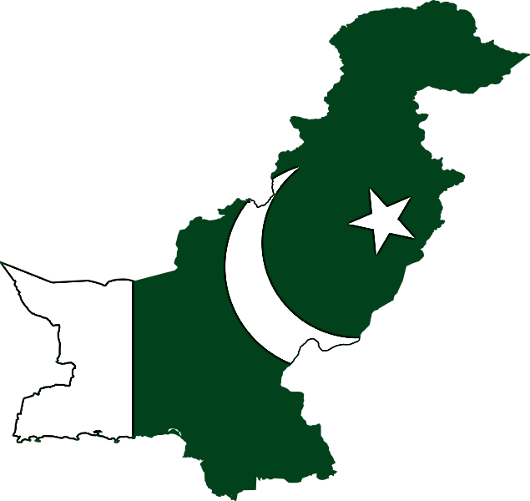
Nothing in the customs law provides for the possibility of preventing imports.
Applicable Legislation
Trade Marks Ordinance 2001 and Trademarks Rules 2004

Does Customs Support/Assist Trademark Owner With PI?
No.

What Procedures Are Available Once PI Enter Country?

Civil Litigation.
What Remedies Are Available?

The position is unclear at present. Contractual law has been used to prevent parallel imports.

Additional Comments
Future interpretation of the Trade Marks Ordinance is expected to lead to injunctions where the trademark is registered in Pakistan.

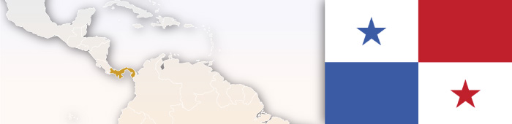

Panama
Type of Exhaustion | Exceptions to Exhaustion
International | None.
Assessment of Parallel Imports
Can Unauthorized Parallel Imports Be Prevented From Entering Country?
No.
Does Customs Support/Assist Trademark Owner With PI?
No.

What Procedures Are Available Once PI Enter Country?

None.
Additional Comments
Notwithstanding the existence of Law No. 45 of 2007 (which regards exclusivity in distribution contracts as an unlawful relative monopolistic practice, in that it diminishes free competition), provided these contacts are not negotiated as exclusive, they are permitted, provided they do create restrictions which may impede economic competition.
What Remedies Are Available?

None.

Paraguay
Assessment of Parallel Imports
Can Unauthorized Parallel Imports Be prevented from entering country?
No. (Art. 17. 1294/98 Paraguayan Trademark Law)
Does Customs Support/Assist Trademark Owners with PI?
No.
What procedures are available once PI enter country?
Type of Exhaustion | Exceptions to Exhaustion
International | Only when the product or its packaging has been remarkable altered, damaged or relabeled.
Administrative Procedures and Civil Litigation.
What remedies are available?
Damages/Contract claims.

Applicable Legislation
Civil Code + art. 84 1294/98 Paraguayan Trademark Law

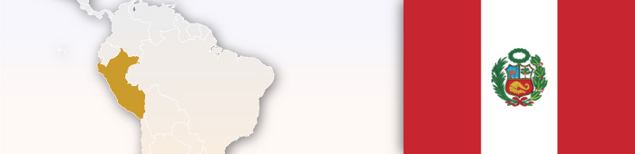

Peru
Type of Exhaustion | Exceptions to Exhaustion
International (+ material differences element) | Only when the product (or its packaging) has undergone a change, alteration, or deterioration.
Assessment of Parallel Imports
Can Unauthorized Parallel Imports Be Prevented From Entering Country?
No.
Does Customs Support/Assist Trademark Owner With PI?
No.
Applicable Legislation
Decision 486 of Andean Community (article 158)

What Procedures Are Available Once PI Enter Country?

Civil litigation.
What Remedies Are Available?

Trademark infringement action, in case the product (or its packaging) has undergone a change, alteration, or deterioration.
Additional Comments
Article 158.- Trademark registration shall not confer on the owner the rights to prevent third parties from engaging in trade in a product protected by registration once the owner of the registered trademark or another party with the consent of or economic ties to that owner has introduced that product into the trade of any country, in particular where any such products, packaging or packing as may have been in direct contact with the product concerned have not undergone any change, alteration, or deterioration. Two persons shall be considered to have economic ties when one of the persons is able to exercise a decisive influence over the other, either directly or indirectly, with respect to use of the trademark right or when a third party is able to exert that influence over both persons.

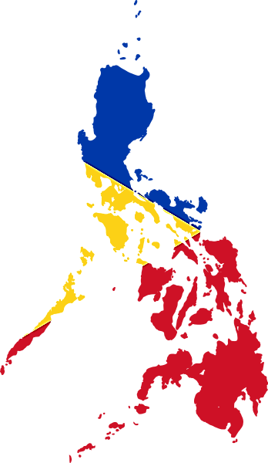
Type of Exhaustion | Exceptions to Exhaustion
National - for copyrights and patented products
International - for drugs and medicines - otherwise there is no national law that directly provides for exhaustion of marks. However, based on the civil law concept of tortious interference, it appears that the principle of national exhaustion may apply to trademarks.

Philippines
Assessment of Parallel Imports
Can Unauthorized Parallel Imports Be Prevented From Entering Country?
Yes.
Does Customs Support/Assist Trademark Owner With PI?
Yes.

What Procedures Are Available Once PI Enter Country?

Court Proceedings; Customs Seizure
What Remedies Are Available?

Injunction; Administrative, Civil or Criminal Action for Unfair Competition; Civil Action for Damages

Applicable Legislation
Rep. Act No. 8293 (Intellectual Property Code), as amended by Rep. Act No. 9502 (The Universally Accessible Cheaper and Quality Medicines Act of 2008)

Key Case Law: Yu vs. Court of Appeals, G.R. 86683, January 21, 1993, 217 SCRA 329



Poland
Type of Exhaustion | Exceptions to Exhaustion
Regional EU-wide
(+ material differences element)

May object to product put into circulation from outside the EEA without its consent. Regional exhaustion may not apply where there are legitimate reasons to oppose where goods are impaired or changed.
Assessment of Parallel Imports
Can Unauthorized Parallel Imports Be Prevented From Entering Country?
Civil litigation - may apply for preliminary injunction which may possibly be ex parte - if an injunction is granted you must follow with a civil suit against the infringer.

Does Customs Support/Assist Trademark Owner With PI?
No.

What Procedures Are Available Once PI Enter Country?

Additional Comments
An action for PI’s may be possible under the Act on Unfair Competition (AUC). Under the AUC, any action which violates the law or goods customs, if it infringes the interests of the clients or another entrepreneur, is considered an act of unfair competition. Remedies include cease and desist, a statement, damages or compensation, or making a payment to a social cause.
Cease and desist. As it is debatable under Polish law as to whether a PI is trademark infringement, remedies for trademark infringement may not always be available. If infringement is found, one may request the surrender of unjustly derived profits and compensation. There may be publication of the judgment.

What Remedies Are Available?

Cease and desist. As it is debatable under Polish law as to whether a PI is trademark infringement, remedies for trademark infringement may not always be available. If infringement is found, one may request the surrender of unjustly derived profits and compensation. There may be publication of the judgment.
Applicable Legislation
Article 155 of the Industrial Property Law

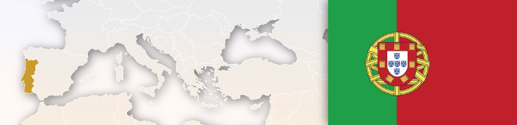

Portugal
Assessment of Parallel Imports
Can Unauthorized Parallel Imports Be Prevented From Entering Country?
To file a custom action application include all the available information (as detailed as possible) about the origin and distribution channels of the PI. It can be very efficient in UPI cases. The owner can expect more inspections to the goods at customs and fast seizures of suspected PI.
Does Customs Support/Assist Trademark Owner With PI?
Yes.

What Procedures Are Available Once PI Enter Country?

Civil action. Criminal action. The proprietor of the trademark may request an administrative raid
by the economic police to prevent the sales of PI.
Type of Exhaustion | Exceptions to Exhaustion
Regional EU-wide (+ material differences element) | May object to product put into circulation from outside the EEA without its consent. Exhaustion may not apply where there are legitimate reasons to oppose where goods are impaired or changed.

What Remedies Are Available?

Seizure/destruction of goods; delivery of infringing articles; order to cease and desist including interim and final injunctions; damages or an account of profits but not both; often information as to origin of goods; judgments are publically available; in certain cases imprisonment.

Qatar
Type of Exhaustion | Exceptions to Exhaustion
International

While the customs law in Qatar is quite restrictive towards counterfeit or fake goods being imported into the country or being exported out from it, these restrictive provisions are not applicable to parallel imported goods. Customs does not restrict or apply any of their restrictions on PI even if they are not meant for that market.
Assessment of Parallel Imports
Can Unauthorized Parallel Imports Be Prevented From Entering Country?

Law no. 9 of 2002 Pertaining to Trademarks, Commercial Indications, Trade Names, Geographical Indications, and Industrial Designs and Models provides, that “if the quantity, size, capacity, power, weight or component elements of the goods are relevant elements in the appreciation of their value, they may not be imported, sold or offered for sale unless one or more of the said indications in Arabic Language are affixed thereon.” If this is not followed, a civil or criminal complaint may be filed. In view of this provision, parallel imports may be restrained on the basis of commercial indication provisions.
Applicable Legislation
Law No. 17 of 2011 on Border Measures to Protect Intellectual Property Rights and law no. 9 of 2002 of Pertaining to Trademarks, Commercial Indications, Trade Names, Geographical Indications, and Industrial Designs and Models.

Does Customs Support/Assist Trademark Owner With PI?
No.

What Procedures Are Available Once PI Enter Country?

Additional Comments
The law is still developing in this jurisdiction and it will be a matter of time for the country to align its imports regulations or agency laws to restrict the incoming of parallel imported goods. Moreover, they also need to strictly implement the law that’s presently available so that parallel imports may be restrained with the aid of prevalent commercial law provisions.
No.
What Remedies Are Available?

The only remedy to secure exhaustion of IP rights in Qatar is by way of contractual obligations. The Local courts usually consider the breach on restriction to export by a purchaser in the same manner as any other contractual obligation between the parties. Accordingly, the court passes order restraining unauthorized exports and/or imports and assesses damages for such breach (loss of profit the and damage sustained). Further, provisions from the commercial indication law could be included.



Republic of Korea
Type of Exhaustion | Exceptions to Exhaustion
International

Parallel imports may be deemed to constitute trademark infringement (exception to the international exhaustion doctrine) if: (i) there is no close legal or economic relationship between the trademark holders (or an exclusive licensee authorized by the trademark holder) in Korea and overseas; (ii) there is a substantive difference in the product quality ; or (iii) the trademark holder in Korea, who is not identical with the trademark holder overseas, has its trademarked goods wholly manufactured in Korea (including the case of OEM).
Assessment of Parallel Imports
Can Unauthorized Parallel Imports Be Prevented From Entering Country?
Even if parallel imports are unauthorized by the trademark owner in Korea or overseas, such parallel imports cannot be prevented from entering the Korean markets, provided that the following requirements are met:
(a) they are parallel imports, not counterfeit goods;
(b) the trademark holder in Korea and the trademark holder overseas are the same or have a legally or economically close relationship so that the sources of the two goods are perceived as being the same; and
(c) there is no substantive difference in product quality between the parallel imported goods and the authentic imported goods.

Does Customs Support/Assist Trademark Owner With PI?
Applicable Legislation
Administrative Notifications (Customs Notifications; Notifications of Unfair Trade Practices related to Parallel Imports)
Customs generally cannot support or assist the trademark holder, even if these parallel imports are unauthorized by the trademark holder.

What Procedures Are Available Once PI Enter Country?

Only if the unauthorized parallel imports do not satisfy any of the requirements (a), (b), or (c), would administrative procedures, as well as civil and criminal action be available.

What Remedies Are Available?

Only if the unauthorized parallel imports do not satisfy any of the requirements (a), (b), or (c), would
administrative remedies (customs’ seizure and destruction of the infringing goods) and Civil and Criminal remedies (permanent or temporary injunction, damage award, seizure and destruction of the infringing goods, imprisonment and fine) be available.

Key Case Law:
Supreme Court Case No. 99Da42322 Burberry Limited vs. E.M.E.C. Co., Ltd;
Supreme Court Case No. 2006Da40423 HanbitSoft Inc. vs. Korean individuals;
Supreme Court Case No. 2012Da9508 Simmons Bed Co., Ltd vs. Karahan Co., Ltd.
Additional Comments
The Korean authorities currently encourage parallel imports in order to stabilize the price of imported goods and to broaden consumers’ choices. Thus, the Customs Office has been lessening its regulations on parallel imports, and in particular has recently implemented a customs clearance certification system for such parallel imports. Under this system, parallel imported goods will be marked with a "customs clearance certification mark for parallel imports" in the form of a Quick Response code during the customs clearance procedure. This clearance certification mark will ensure consumers that the goods have been imported via parallel import channels, by enabling consumers to identify the relevant particulars of the goods, including the name of the importer, the origin, the brand, the model, and the import declaration date.

Romania
Assessment of Parallel Imports
Can unauthorized parallel imports be prevented from entering country?
Yes. Civil litigation, including by way of a preliminary injunction, in some cases even ex-parte.
Does Customs support/ assist trademark owner with PI?
No
What procedures are available once PI enter country?
- C&D Letter to the importer in order to withdraw the goods from the Romanian market;
- Civil Action for trademark infringement including a motion for preliminary injunction
- Criminal Proceedings – No. There were several cases in which the trademark owners attempted to claim criminal liability, in order to keep the products seized during the criminal investigations. However it has been determined that the parallel imports do not trigger criminal liability.
What remedies are available?
Type of Exhaustion | Exceptions to Exhaustion
Regional. EU-wide (+material differences element) | Absence of consent and a legitimate reason for the proprietor to oppose further commercialization of the goods, especially where the condition of the goods is changes or impaired after they have been put on the market.
- Seizure;
- Damages;
- Information – Upon request of the trademark owner, the Court may order the importer to disclose all information including consignee, consignor and other intermediaries;
- Recall of the goods;
Applicable Legislation
Articles 36 and 38 of the Romanian Trademark Law no. 84/1998
- Return of the goods to the exporter or destruction of the goods.



Russia
Type of Exhaustion | Exceptions to Exhaustion
National (but perhaps within Russia, Belarus and Kazakhstan). Movement to international exhaustion pending. | None.
Assessment of Parallel Imports
Can Unauthorized Parallel Imports Be Prevented From Entering Country?
Recording of trademarks with customs will prevent importation by parties who are not authorized importers. Also civil litigation. Also out of court negotiation.
Applicable Legislation
Broad definition of counterfeit goods - no definition of parallel imports - Article 1515 of the Russian Federation for counterfeits is sometimes construed to apply to parallel imports - "the goods, labels, packaging of goods on which a trademark or a designation similar thereto to the extent of confusion has been illegally placed are counterfeit.

Does Customs Support/Assist Trademark Owner With PI?
Yes - should register marks with customs registers of Objects of intellectual Property - Article 330 of the Customs Code of Customs Union.

What Procedures Are Available Once PI Enter Country?

Customs may detain for 10 business days with an option to extend by 10 more days. Customs may call administrative proceedings by bringing a civil claim to the state arbitrazh court. Civil litigation may also be possible, especially if goods are inferior (either by courts of arbitrazh or state civil courts). Also criminal liability under Russian criminal law, if you can prove all elements of a crime are present - article 180 of the Criminal Code of the Russian Federation.

What Remedies Are Available?

Additional Comments
Section 28(3) refers to international exhaustion. No precedent on parallel imports.
Seizure/destruction of goods and devices used to commit infringement; order to cease and desist; damages; often information as to origin of goods and distribution network; publication of the judgment; fines and imprisonment.

Saint Martin
Type of Exhaustion | Exceptions to Exhaustion
International None.
Assessment of Parallel Imports
Can Unauthorized Parallel Imports Be Prevented From Entering Country?
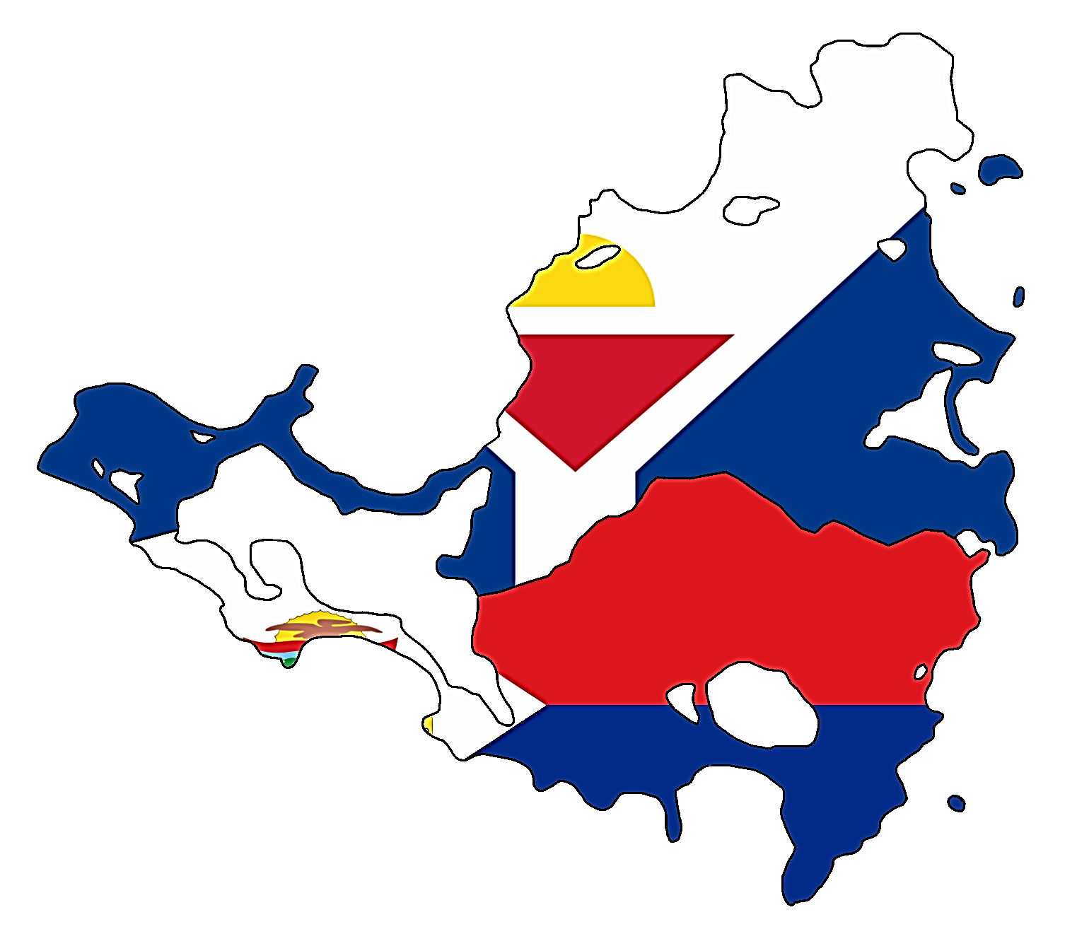
No
Does Customs Support/Assist Trademark Owner With PI?
No

What Procedures Are Available Once PI Enter Country?

None

What Remedies Are Available?

No legal mechanism

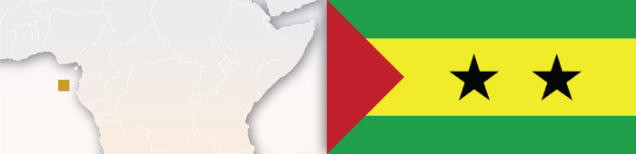

São Tomé and Principe
Type of Exhaustion | Exceptions to Exhaustion
International | None.
Assessment of Parallel Imports
Can Unauthorized Parallel Imports Be Prevented From Entering Country?
No.
Does Customs Support/Assist Trademark Owner With PI?
No.

What Procedures Are Available Once PI Enter Country?

None.
What Remedies Are Available?

None.


Serbia
Assessment of Parallel Imports
Can Unauthorized Parallel Imports Be Prevented From Entering Country?
If goods have been intentionally or unintentionally modified, there is inappropriate marking or extremely low pricing, all may jeopardize the reputation of the mark - however in practice it is difficult to stop the parallel import in Serbia.

Does Customs Support/Assist Trademark Owner With PI?
No.

What Procedures Are Available Once PI Enter Country?
Type of Exhaustion | Exceptions to Exhaustion
International (+ material differences element) | Under section 40(2) of the Serbian Trademark Law, exhaustion shall not apply where there exists legitimate reasons to oppose commercialization - where goods are changed or impaired after being put into market - without the owner's consent.

None.
What Remedies Are Available?

None.



Sierra Leone
Assessment of Parallel Imports
Type of Exhaustion | Exceptions to Exhaustion
International | None.
Can Unauthorized Parallel Imports Be Prevented From Entering Country?
There seems no prevention offered in local Sierra Leones laws as the country follows international exhaustion
Does Customs Support/Assist Trademark Owner With PI?
Customs would not be able to provide any logical support as legally there are no restrictions imposed.

What Procedures Are Available Once PI Enter Country?

PI’s usually are not restricted and hence are sold freely in local markets.

What Remedies Are Available?

The local distributor can seek some redress from the authorities responsible for weights and measures and standardization of products

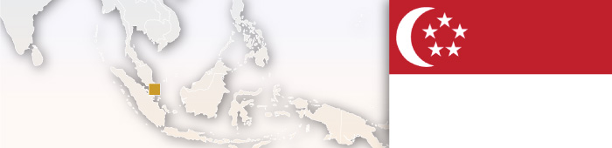
Type of Exhaustion | Exceptions to Exhaustion
International
Trademarks: (1) The goods were put on the market without the consent of the mark proprietor or (2) the condition of the goods were impaired and there was unfair dilution or (3) the law on passing off applies.
Patents: (1) The goods were not produced by or with the consent of the proprietor of the patent or (2) the import was of a pharmaceutical product which, inter alia, would result in the product being distributed in breach of a contract between the patent proprietor and any licensed distributor (Section 66(3) SGPA) or (3) the import was of any relevant health product produced for export to any country, other than Singapore, which is an eligible importing member of the World Trade Organization (Section 66(5A) SGPA).
Copyrights: The article in question was not made with the consent of the copyright owner in their country of manufacture.
Registered Designs: The goods were put on the market without the consent of the mark proprietor.

Singapore
Assessment of Parallel Imports
Can Unauthorized Parallel Imports Be Prevented From Entering Country?
Only where the exceptions are applicable or some form of misrepresentation can be demonstrated such as to amount to passing off.

Singapore’s exceptions certainly indicate that there is an inclination to the hybrid approach.
Does Customs Support/Assist Trademark Owner With PI?
No. However, if the goods qualify as those within exceptions, customs should take an action.

What Procedures Are Available Once PI Enter Country?

Civil litigation, only in case if it is proved that the import and the goods qualify within the exceptions.

What Remedies Are Available?

Cease and desist, interim and final injunctive reliefs, damages (loss of profits or account), delivery and costs.

Applicable Legislation
Trade Marks Act 2005
Patents Act of 1994
Copyright Act 1987
Registered Designs Act 2005
Key Case Law: (1) Sin Heak Hin Pte ltd v Yuasa Battery Singapore Co Pte Ltd [1995] SGHC 208 (2) Remus Innovation forschungs-Und Abgasanalagen-Produktionsgesellschaft mbH v Hong Boon Siong [1998] SgHC 217 (3) Yunnan baiyao Group Co Ltd (formerly known as Yunnan Baiyao Industrial Co Ltd) v Tong Jum Chew Pte Ltd [2002]SGHC 246 (4) Pan-West (Pte) Ltd v Grand Bigwin Pte Ltd [2003] SGHC 250

Slovakia
Type of Exhaustion | Exceptions to Exhaustion
Regional EU-wide (+ material differences element) | Does not apply where there is legitimate reason for the owner to oppose further commercialization - where the goods are changed or impaired without the owner's consent after being put on market. National exhaustion outside the EEA.
Assessment of Parallel Imports
Can Unauthorized Parallel Imports Be Prevented From Entering Country?
Civil litigation if the goods are infringing - can also seek a preliminary injunction. Criminal proceeding may be possible (such as criminal offence violation of trademark, designation of origin and business name rights).


Does Customs Support/Assist Trademark Owner With PI?
No.

What Procedures Are Available Once PI Enter Country?

Civil litigation - criminal action.

What Remedies Are Available?

Seizure/destruction of infringing goods; no seizure of devices or containers; order to cease and desist; damages/compensation; information pertaining to origin of goods; publication of judgment; imprisonment if criminal offense; unjust enrichment may be able to be claimed.

Applicable Legislation
Article 50 of the Slovenian Industrial Property Act
Key Case Law: The issue of the owner's consent to distribution of goods is interpreted in Court of Justice of the European Union case law (such as C-414/99 and C-416/99) - no relevant Slovak case law is available.

Additional Comments
Section 28(3) refers to international exhaustion. No precedent on parallel imports.



Type of Exhaustion | Exceptions to Exhaustion
Regional EU-wide (+ material differences element) | Does not apply where there is legitimate reason for the owner to oppose further commercialization - where the goods are changed or impaired without the owner's consent after being put on market.

Slovenia
Assessment of Parallel Imports
Can Unauthorized Parallel Imports Be Prevented From Entering Country?
Civil litigation if the goods are infringing - can seek a preliminary injunction.

Does Customs Support/Assist Trademark Owner With PI?
No.

What Procedures Are Available Once PI Enter Country?

Additional Comments
Rule of exhaustion for copyright/designs/patents is less favorable than trademarks.
Civil litigation - infringement action under Article 121 of the Slovenian Industrial Property Act; possibly Article 13 of the Slovenian Protection of Competition Act for unfair competition; civil action on the basis of breach of contractual obligations if applicable between the trademark holder and the parallel importer; possibly criminal proceedings (although no precedent was located) .

What Remedies Are Available?

Seizure/destruction of infringing goods and containers; order to cease and desist; damages/compensation; information pertaining to origin of goods; publication of judgment; imprisonment if criminal offense.

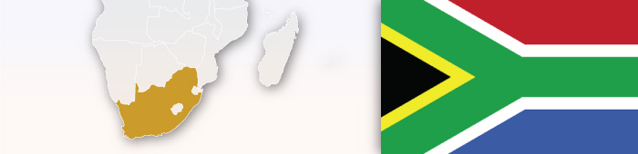

South Africa
Type of Exhaustion | Exceptions to Exhaustion
International (+ material differences element) | None, unless goods themselves are altered.
Assessment of Parallel Imports
Can Unauthorized Parallel Imports Be Prevented From Entering Country?
No.
Applicable Legislation
Trade Marks Act 194 (1993); Consumer Protection Act (2008); Copyright Act 98 (1978)
Does Customs Support/Assist Trademark Owner With PI?
No.

What Procedures Are Available Once PI Enter Country?

None.
What Remedies Are Available?

None.
Additional Comments
1. "Passing off" may occur if the distributor enjoys an independent reputation in the country where the goods are ultimately sold. The success of such an action depends upon whether the requirements of a passing off can be proved, i.e., that the reputation vests in the distributor and that the use of the mark is likely to deceive or cause confusion.
2. In terms of Section 25(2) of the Consumer Protection Act ("CPA"), a person who markets any goods bearing a trademark, which have been imported without the approval or license of the registered owner of that trademark, must apply a conspicuous notice to those goods in the prescribed manner and form.
Key Case Law: Protective Mining & Industrial Equipment Systems (Pty) Limited (formerly Hampo Systems (Pty) Limited v Audio lens (Cape) (Pty) Limited.; Frank & Hirsch (Proprietary) Limited v A Roopanand Brothers 1993 (4) SA 279 (A).
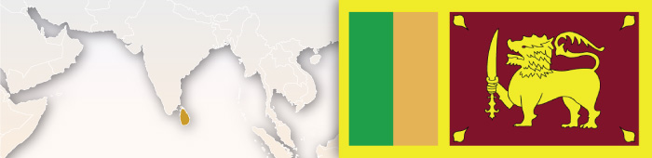

Sri Lanka
Type of Exhaustion | Exceptions to Exhaustion
International (+ material differences element) | If goods have undergone a change, then, under Section 122 of the Intellectual Property Act, importation may be restrained.
Assessment of Parallel Imports
Can Unauthorized Parallel Imports Be Prevented From Entering Country?
Yes, if goods have undergone a change.

Does Customs Support/Assist Trademark Owner With PI?
Yes, if you can demonstrate the change to customs.
Applicable Legislation
Section 122 of the Intellectual Property Act

What Procedures Are Available Once PI Enter Country?

Civil litigation.

What Remedies Are Available?

Injunctions through a civil court.

Key Case Law: There is very little case law on the matter.

Additional Comments
Section 28(3) refers to international exhaustion. No precedent on parallel imports.

Sudan
Type of Exhaustion | Exceptions to Exhaustion
International

The ‘Sudan trademark law’ (Law no. 8 of 1969), ‘Sudan customs act’ (Act no. 11 of 1986), ‘Sudan Imports and export act of 2012’ (South Sudan) does not have specific provisions to stop parallel importing. The ‘Weights and measures act of 2012’ (South Sudan) deals with weights and measures and have certain restrictive provisions about the standards of weights and measures under which the goods should be manufactured or sold in the local markets.
Assessment of Parallel Imports

Can Unauthorized Parallel Imports Be Prevented From Entering Country?
No.
Does Customs Support/Assist Trademark Owner With PI?
No.

What Procedures Are Available Once PI Enter Country?

No.
What Remedies Are Available?

No.

Applicable Legislation
The ‘Sudan trademark law’ (Law no. 8 of 1969), ‘Sudan customs act’ (Act no. 11 of 1986), ‘Sudan Imports and export act of 2012’ (South Sudan) does not have specific provisions to stop parallel importing.

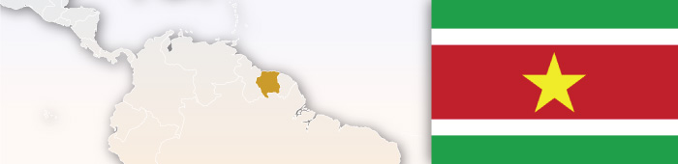

Suriname
Type of Exhaustion | Exceptions to Exhaustion
International | None.
Assessment of Parallel Imports
Can Unauthorized Parallel Imports Be Prevented From Entering Country?
No.
Applicable Legislation
Suriname Law is still largely based on Dutch Law. There are no legal dispositions concerning parallel imports or customs regulations.
Does Customs Support/Assist Trademark Owner With PI?
No.

What Procedures Are Available Once PI Enter Country?

None.

What Remedies Are Available?

None.

Additional Comments
Section 28(3) refers to international exhaustion. No precedent on parallel imports.


Sweden
Type of Exhaustion | Exceptions to Exhaustion
Regional EU-wide (+ material differences element) | If the rights holder has a "reasonable justification" for opposing the sale of the goods - including if the goods are altered or reduced after being put on the market - without the consent of the owner.
Assessment of Parallel Imports
Can Unauthorized Parallel Imports Be Prevented From Entering Country?
No.
Does Customs Support/Assist Trademark Owner With PI?
No.

What Procedures Are Available Once PI Enter Country?
Applicable Legislation
Swedish Trademark Act chapter 1 section 12 para 2

Civil litigation - prohibitory injunction, interim injunction, order to provide information; criminal proceeding (rarely) - usually only if in the public interest with potentially harmful products or large scale counterfeits.
Additional Comments
Although Swedish customs do not have authority to act against PI, active involvement and co-operation with customs is advisable. Filings with customs to prevent counterfeit is possible, and by having an application in place, the rights holder increases the chances that the customs occasionally identify and notify the rights holder of the UPI.

What Remedies Are Available?

Seizure/destruction of infringing goods and devices or containers; order to cease and desist; damages/compensation; information pertaining to origin of goods; publication of judgment; imprisonment if criminal offense; fines; infringement investigation; forfeiture of property appurtenant to a crime as well as property used as an instrument of criminality.

Switzerland
Type of Exhaustion | Exceptions to Exhaustion
International (+ material differences element)
If goods are placed on market without the owner's consent, and if they were merely sold to an affiliate within a group of companies, or if the essential characteristics of a product were or have changed after it was put into the market (different product appearance, quality, shelf life).
Assessment of Parallel Imports
Can Unauthorized Parallel Imports Be Prevented From Entering Country?

Civil litigation; criminal action for willful trademark infringement under the Swiss Trademark Act; writing a cease and desist letter. Customs is of assistance for trademark infringement, but it is more difficult for PI due to exhaustion principle (more difficult to get customs to take action).

Does Customs Support/Assist Trademark Owner With PI?
Customs is of assistance for trademark infringement (notification, temporary detention of goods, taking samples), but it is more difficult for PI’s due to exhaustion principle (more difficult to get customs to take action).
Additional Comments
Asserting copyrights may be helpful, but the courts still follow the doctrine of international exhaustion. Unfair competition law may be of assistance. Prices for Swiss goods are generally higher, such that parallel imports are considered important to reduce the price level.

What Procedures Are Available Once PI Enter Country?

Civil or criminal litigation.

What Remedies Are Available?

Seizure/destruction of infringing goods; usually no seizure of devices or containers; order to cease and desist; damages/compensation; information pertaining to origin of goods; publication of judgment; imprisonment if criminal offense; account for profits and disgorgement.

Key Case Law: Swiss Federal Court ruled that international exhaustion applies. Also note a recent cantonal court decision where the alleged infringer did not have to bear the burden to prove the defense of exhaustion - the owner had to bear the burden to prove differences in the products in question.

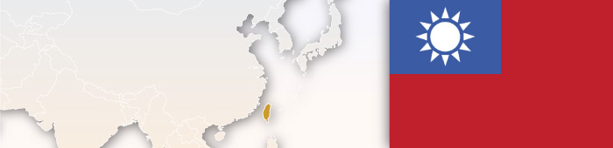

Taiwan
Type of Exhaustion | Exceptions to Exhaustion
International (+ material differences element) | (a) If the condition of the goods would be changed or impaired after they are put on the market; or (b) other legitimate reasons.
Assessment of Parallel Imports
Can Unauthorized Parallel Imports Be Prevented From Entering Country?
Yes. If any of the exceptions exists, the trademark owner may file an application to customs for detention of goods believed to be infringing. Customs detention is only possible upon the applicant’s placing a security in an amount equivalent to the duty-paid price of the target imported goods, assessed by customs, or assurance of equivalent value. So, a hybrid system of material difference is adopted.
Applicable Legislation
Trademark Act 2011, Article 36

Does Customs Support/Assist Trademark Owner With PI?
Yes, but cases are few.

What Procedures Are Available Once PI Enter Country?
Additional Comments
PI’s entering into Taiwan over internet commerce has become a new and difficult issue for trademark owner recently.

Civil litigation, criminal action.

What Remedies Are Available?

Seizure/destruction of infringing goods, seizure/destruction of devices used to commit infringement, order to cease and desist, damages/compensation, publication of judgment, fines/imprisonment.

Key Case Law: Trademark infringement occurs if the unauthorized parallel imported goods are sold in Taiwan after unauthorized processing, modification or change, yet still bearing the same trademark, to the extent that consumers should be misled. 99 Shen Zhi Yi 43, Kaohsiung District Court, 2011.

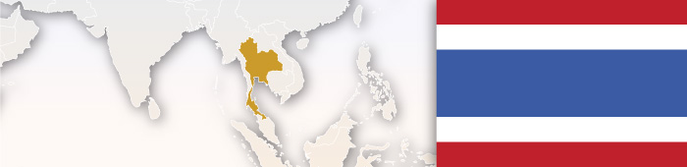

Thailand
Type of Exhaustion | Exceptions to Exhaustion
International | None.
Assessment of Parallel Imports
Can Unauthorized Parallel Imports Be Prevented From Entering Country?
Thailand adopts the international exhaustion and thereby unauthorized PI is allowed to enter the country.
Applicable Legislation
Patent: Section 36(7) of the Patent Act B.E. 2522 (1979), as amended by the Patent Act (No. 2) B.E. 2535 and the Patent Act (No. 3) B.E. 2542;
Copyright: Section 32/1 of the Copyright Act B.E. 2537 (1994), to be amended by the Copyright Act (No. …) B.E. … (passed The National Legislative Assembly in November 2014 and is now awaiting the Royal Assent)

Does Customs Support/Assist Trademark Owner With PI?
The legal provisions In the customs law do not have any supportive provisions to assist trademark owners on PI.
What Procedures Are Available Once PI Enter Country?

PI are allowed free entry into the market unless there are any restrictions from the weights and measures laws to disallow the goods from being sold in the local market. What Remedies Are Available?

None.
Key Case Law: Trademark: WAHL vs. P.C.L. Co., Ltd. Supreme Court Case No. 2817/2543
Additional Comments
In Supreme Court Case No. 2817/2543, Wahl Clipper Corporation vs. P.C.L. Co., Ltd., it is confirmed that parallel imports are not an infringement because the activity is valid under the doctrine of international exhaustion. Once the trademark owner places the product into the market anywhere in the world, the trademark owner is no longer entitled to take any legal action against a third party for selling a parallel import in Thailand based on trademark infringement. Although Thailand does not recognize stare decisis, Thai Courts will generally follow the higher court’s previous decisions, particularly Supreme Court decisions.

Trinidad and Tobago
Type of Exhaustion | Exceptions to Exhaustion
International | None.
Assessment of Parallel Imports
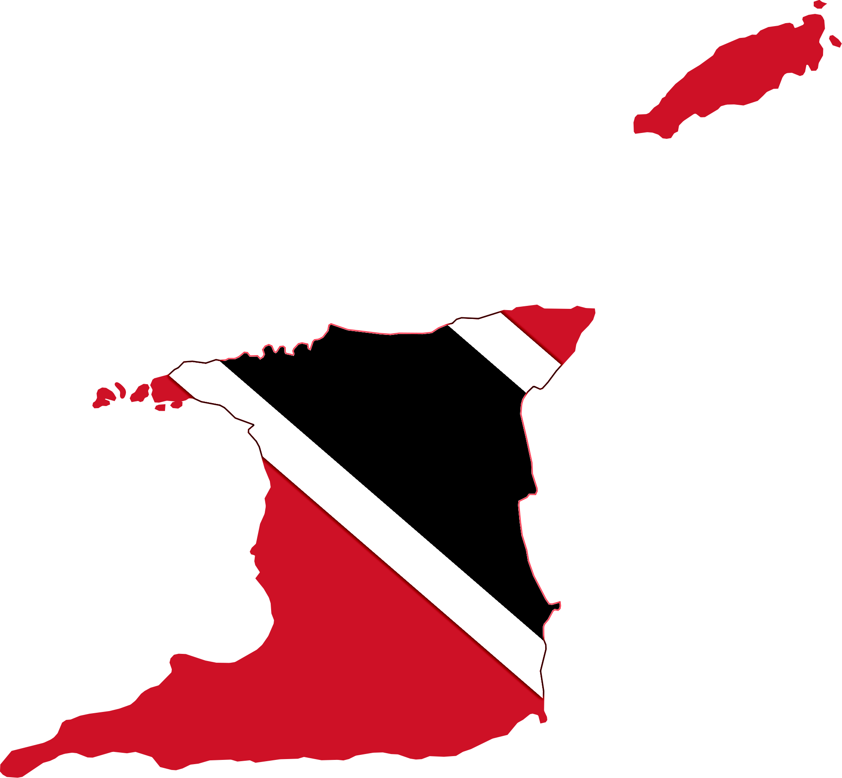
Can Unauthorized Parallel Imports Be Prevented From Entering Country?
No.
Does Customs Support/Assist Trademark Owner With PI?
No.

What Procedures Are Available Once PI Enter Country?
Additional Comments
A new Trade Marks Act (passed by the Parliament in 2015 but not yet proclaimed) intends to apply international exhaustion rights. Other forms of redress may be based on principles of contract law provisions under the Protection Against Unfair Competition Act (protection against commercial/industrial activities contrary to honest business practices in respect of trademarks, trade secrets) or the Fair Trading Act ( anti-competition legislation), due to be proclaimed in 2017.

None.

What Remedies Are Available?

None.

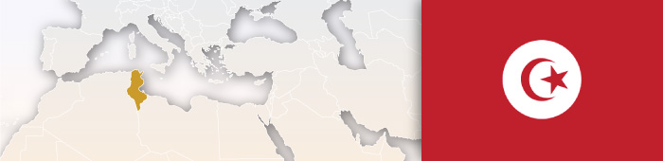

Tunisia
Type of Exhaustion | Exceptions to Exhaustion
International

Assessment of Parallel Imports
Can Unauthorized Parallel Imports Be Prevented From Entering Country?
Tunisia adopts the international exhaustion and thereby unauthorized PI is allowed to enter the country.
Does Customs Support/Assist Trademark Owner With PI?
No, the legal provisions in the customs law do not have any supportive provisions to assist trademark owners on PI.

What Procedures Are Available Once PI Enter Country?

PI are allowed free entry into the market unless there are any restrictions from the weights and measures laws to disallow the goods from being sold in the local market.
What Remedies Are Available?

None.

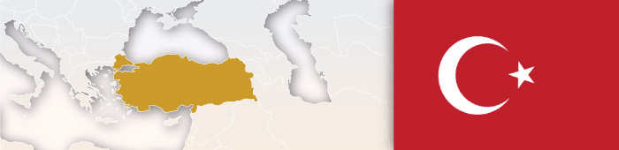

Turkey
Assessment of Parallel Imports
Type of Exhaustion | Exceptions to Exhaustion
International (+ material differences element) | Exhaustion does not apply if the original goods are changed or impaired, the brand owner could stop commercialization of such products.
Can Unauthorized Parallel Imports Be Prevented From Entering Country?
No.

Does Customs Support/Assist Trademark Owner With PI?
Sometimes, see exceptions..

What Procedures Are Available Once PI Enter Country?

Civil litigation, in case of exceptions..

What Remedies Are Available?

Seizure/destruction of the infringing goods, order to cease and desist, limited damages, publication of judgment.


Type of Exhaustion | Exceptions to Exhaustion
Regional (CARICOM) (+ material differences element) | By virtue of Section 27 (2) of the Trade Marks Ordinance, exhaustion will not apply where there exists legitimate reasons for the proprietor to oppose further dealings in the goods (in particular, where the condition of the goods has been changed or impaired after they have been put on the market).

Turks and Caicos Islands
Assessment of Parallel Imports
Can Unauthorized Parallel Imports Be Prevented From Entering Country?
No.

Does Customs Support/Assist Trademark Owner With PI?
No.

What Procedures Are Available Once PI Enter Country?

None.
Applicable Legislation
The Trademarks Ordinance. Section 27 (1) of the Trade Marks Ordinance provides that, "A registered trade mark is not infringed by the use of the trade mark in relation to goods which have been put on the market in the CARICOM Single Market and Economy under that trade mark by the proprietor or with his consent." Once goods have been put on the market by the proprietor or with its consent, its registered trademark cannot be used to prevent further dealings in the goods and the rights in the trademark are exhausted. Members of CARICOM: Antigua and Barbuda, The Bahamas, Barbados, Belize, Dominica, Grenada, Guyana, Haiti, Jamaica, Montserrat, Saint Lucia, St. Kitts and Nevis, St. Vincent and the Grenadines, Suriname and Trinidad and Tobago. Associate members of CARICOM: Anguilla, Bermuda, British Virgin Islands, Cayman Islands, Turks and Caicos Islands.

What Remedies Are Available?

None.

Ukraine
Type of Exhaustion | Exceptions to Exhaustion
Unclear. Ukrainian legislation does not define exhaustion of rights or parallel import. In view of that, the law is often interpreted to state that the international principle is applied. (+ material differences element) | Where the quality or condition of the goods has been changed or impaired - Article 16 of the Law of Ukraine "On the Protection of rights to Marks for Goods and Services". Repackaging and labeling is likely infringement.
Assessment of Parallel Imports

Can Unauthorized Parallel Imports Be Prevented From Entering Country?
No.
Does Customs Support/Assist Trademark Owner With PI?
Trademark owners are not provided with tools to prevent importation and clearance of PI. However, the customs register provides for the recordal of information on authorized importers, which means that a trademark holder may be alerted about unauthorized imports to consider taking legal steps once the goods are in the internal market.

What Procedures Are Available Once PI Enter Country?

Applicable Legislation
The Law of Ukraine "On the Protection of Rights to Marks for Goods and Services", no. 3689-XII of 1993 (Trademark Law).

Civil litigation (contractual action).

What Remedies Are Available?

Remedies provided under: a) Civil Code in case of breach of contract; b) Consumer Protection Act; c) Competition Act (in case there is taking unfair advantage over authorized distributors); d) Tax laws (in case customs values are decreased and relevant taxes are not collected).



United Arab Emirates (UAE)
Type of Exhaustion | Exceptions to Exhaustion
International

The only scope of restraining PI is by the application of agency law. However, agency law is not applicable in certain cases; thereby the restrictive provisions to safeguard against parallel imports are not applicable under these circumstances:
A. Exemption of basic food items: In October 2005, following price increases, the Ministry exempted a list of basic food items from the coverage of the Trade Agencies Law. As per Cabinet Decision N°538/1, the following food items fall beyond the scope of the Agencies law:
• Dry and condensed milk;
• frozen and canned vegetables;
• children's foodstuff and milk;
• chickens; cooking oil; rice; flour;
• fish products; meat and meat products;
• tea; coffee;
• cheese; pasta (macaroni, vermicelli);
• sugar; and
• Diapers.
It is concerning that import of goods in any of the above sectors thereby would not be screened as per the applicable agency law by customs. An obvious consequence is the rise of parallel imports in such sectors.
Assessment of Parallel Imports
Can Unauthorized Parallel Imports Be Prevented From Entering Country?
Specifically, Article 23 of Federal Law No. 18 of 1981 (as amended), provides:
No one shall be allowed to import goods, products, manufactured materials or items or other properties subject to any commercial agency entered in the Registry of the Ministry in the name of a third party for the purpose of trading through a channel other than that of the Agent.
Customs departments in the Emirates shall not release items imported through other than the agent’s channel without the approval of the Ministry or the Agent. Customs departments and competent authorities in the Emirates, each according to its competency, and upon requests of Agent addressed through the Ministry, shall impound such imported items and deposit them in the Port’s stores or importer’s stores until the dispute has been settled.

Does Customs Support/Assist Trademark Owner With PI?
The trademark owner is not directly provided with rights to restrain PI. Nonetheless, the registered local agent has rights. Customs Departments are the appropriate authorities to whom a commercial agent should direct its complaint regarding unauthorized importation of goods/parallel imported goods, which are the subject of a commercial agency agreement. The wording of Article 23 also indicates that the instructions of the Ministry of Economy, based on a complaint filed by a registered agent, are required in order to have Customs Departments act against parallel importation.

What Procedures Are Available Once PI Enter Country?

Civil litigation.

Applicable Legislation
Federal Law No. 18 of 1981 (Agencies Law)

What Remedies Are Available?

Seizure/destruction of infringing goods.

Additional Comments
Few of the possible changes:
• An amendment of the local Agencies law to provide even unregistered agents the rights to restrain parallel imports.
• To remove the pre-condition of exclusivity in agency in order to apply such provisions.
• Provide rights to the principal or the trademark owner to restrain any unauthorized import in the country.
• Even if IPR legislations (including the trademark, copyright, patents and designs acts) are amended to include the doctrine of exhaustion of IPR rights, they should be limited to domestic/national exhaustion doctrine only.
• If agency law cannot be applied in certain sectors (as has been mentioned in section 4A above) there has to be a basic amendment of the IPR regulations providing the IP owner the rights to restrain parallel imports across all sectors of goods.
Key Case Law: In October 2009, six foreigners trading in the UAE were jailed after being convicted of engaging in parallel imports. Dubai Courts handed down the sentence which is the first ever imprisonment related to the sale of "gray" products in the Middle East. The ruling followed a raid by authorities against a major parallel importer in Dubai, which led to the confiscation of thousands of DVDs containing banned titles. Six people including the shop manager were arrested, with the manager sentenced to two months in prison, a fine of AED 20,000 and deportation. The name of the shop was not released.

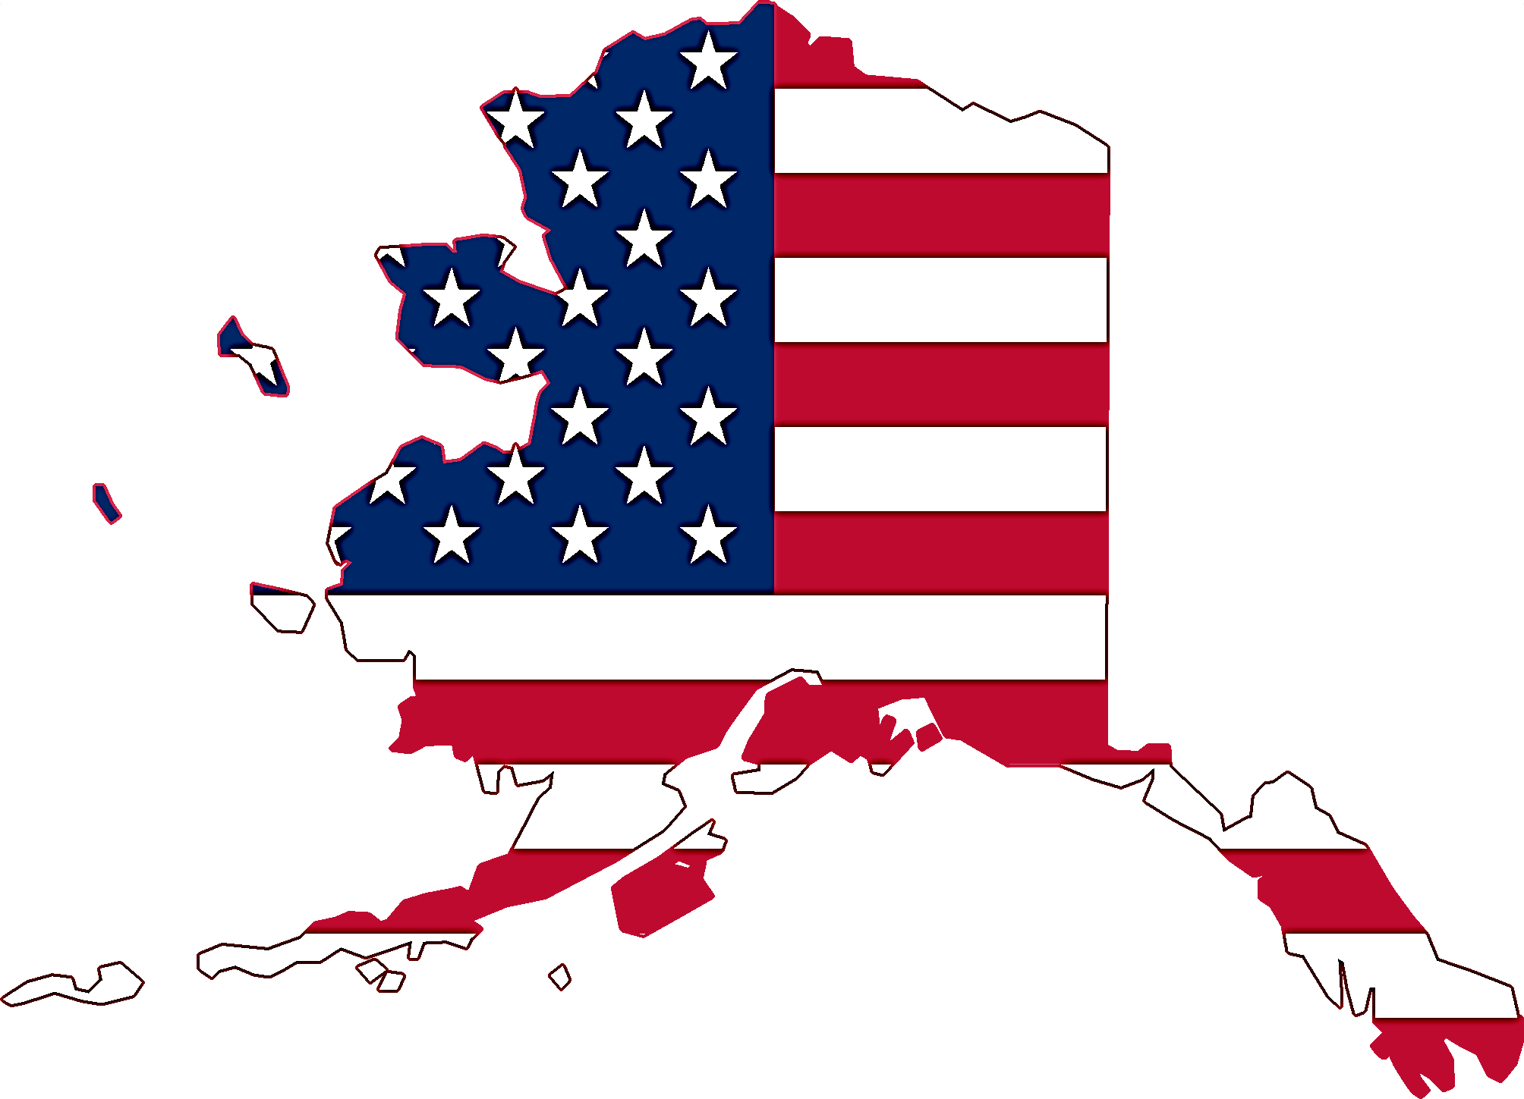
United States of America
Type of Exhaustion | Exceptions to Exhaustion
Material Differences Standard
The US generally applies the principle of international exhaustion, but goods may only be allowed for importation if they come from a company which is affiliated with the brand owner, and they are not materially different from those marketed in the United States. In the US, the brand owner is able to stop imports if they differ materially in relation to, for example, formulation, fragrance, color, calories, lot code removal, size, fill volume, packaging, language, guarantees, labeling and instructions.
Assessment of Parallel Imports
Can Unauthorized Parallel Imports Be Prevented From Entering Country?
Yes.
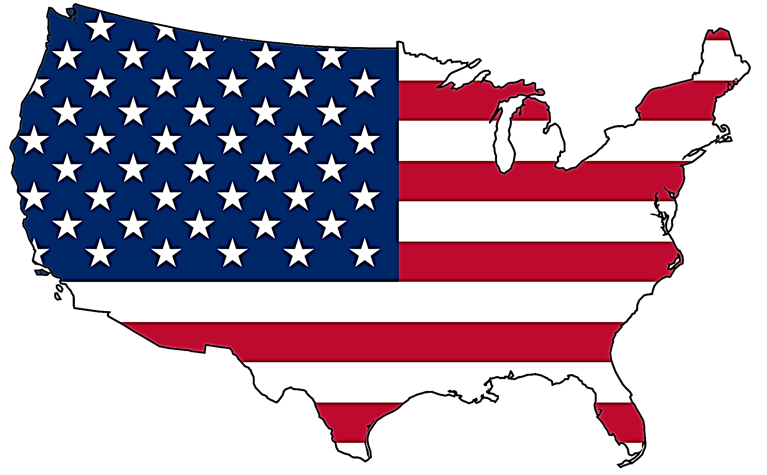
Does Customs Support/Assist Trademark Owner With PI?
Yes, but there must be physical and material differences between the parallel imports and the authorized goods, subject to a disclaimer workaround. Customs will also enforce an order of the court or the International Trade Commission.

What Procedures Are Available Once PI Enter Country?

Applicable Legislation
Sections 32, 42, and 43(a) of the Lanham Act (15 U.S.C. §§ 1114(1)(a), 1124 and 1125(a)(1)), Section 526 of the Tariff Act (19 U.S.C. § 1526), U.S. Customs and Border Protection (CBP)
Regulations at 19 C.F.R. §§ 133.2 to 133.27
U.S. Customs and Border Enforcement (CBP) will prevent the importation of goods under Section 42 of the Lanham Act only if the trademark owner applies for Lever rule protection and demonstrates that the imported goods are physically and materially different than the authorized goods sold in the U.S. Lever rule protection is available to the owner of a mark that is registered with the USPTO and recorded with CBP, even if the owner is a foreign company or the owner is a U.S. company and the foreign goods are manufactured by a corporate affiliate. Lever rule protection is also available to a trademark owner who has recorded its trade name with CBP, provided that the trade name is displayed on the parallel imports. The importer may comply with the Lever rule, however, by affixing a certain disclaimer to the goods which allows for their importation.
CBP will prevent the importation of goods under Section 526 of the Tariff Act without any showing of physical or material differences, but only where the owner of the mark is a U.S. company and the foreign goods are not manufactured by a party under common ownership or control. In some circumstances CBP may deny Tariff Act protection where the U.S. trademark owner owns a trademark registration in the country of manufacture. An importer may not defeat the protections of the Tariff Act by use of a disclaimer.
Trademark owner may also institute a civil lawsuit for an injunction and damages or an International Trade Commission proceeding, in which case only material differences (and notr physical and material differences) need to be proven. In addition, a trademark owner, may try to bar importation through US patent laws where applicable.

What Remedies Are Available?

Seizure. Destruction; damages; injunction.

Trademark owners may also institute a civil lawsuit for an injunction and damages in federal court or in an International Trade Commission proceeding, in which case only material differences (and not physical and material differences) need to be proven. In addition, a trademark owner may try to bar importation through US patent laws where applicable.

Key Case Law: Lever Bros. v. United States, 981 F.2d 1330 (D.C. Cir. 1993



Uruguay
Type of Exhaustion | Exceptions to Exhaustion
International (+ material differences element) | If the product's appearance, packaging or container has been altered, modified or significantly damaged.
Assessment of Parallel Imports
Can Unauthorized Parallel Imports Be Prevented From Entering Country?
No.
Does Customs Support/Assist Trademark Owner With PI?
No.

Applicable Legislation
Trademarks Law 17011 Section 12

What Procedures Are Available Once PI Enter Country?

Civil litigation.

What Remedies Are Available?

Damages/compensation. Permanent injunction to cease commercialization of the products.

Key Case Law:
Sony Corporation c. P.C.S.A. y otros J. Civ. 5º Turno.; Nº 5/03; 15/02/2003
Additional Comments
It is only possible to start a civil procedure to stop commercialization and recover damages in the case of goods in infringement of Section 12, that is, provided that products and their appearance, packaging or container have been altered, modified or significantly damaged. It is understood that Uruguayan Copyright Law sets forth the national exhaustion of rights principle in regard to copyrighted works. Therefore, if a product is afforded copyright protection in addition to trademark protection, resorting to copyright regulations could be an effective measure in order to prevent the introduction of Parallel Imports to the market.
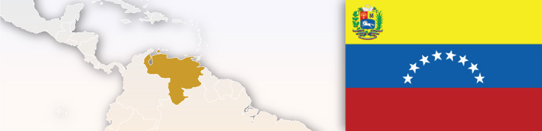

Venezuela
Type of Exhaustion | Exceptions to Exhaustion
International | None.
Assessment of Parallel Imports
Can Unauthorized Parallel Imports Be Prevented From Entering Country?
Venezuelan legislation does not provide specific regulation for parallel imports. Nevertheless, according to the majority of the doctrine, the parallel imports could be considered as legal.
Additional Comments
Current applicable Industrial Property Law does not provide any regulation regarding Parallel Imports. Decision 486 of the Andean Pact, has an article that, in principle, implies that parallel imports are legal. Even though Venezuela is no longer a member of the Andean pact, Decision 486 is still considered relevant.

Does Customs Support/Assist Trademark Owner With PI?
No.

What Procedures Are Available Once PI Enter Country?

Civil litigation.

What Remedies Are Available?

Venezuela legislation does not provide a remedy in itself. In any case, it would be required that such conduct must be considered as an infringement of Trademark Acts.

The definition of parallel imports in Venezuela is the same accepted in other countries, i.e., importation of genuine goods without authorization/license of the owner of the IP right related to the imported goods.
Infringement of IP rights: The importation without authorization is considered a violation of IP rights (trademark registration) in Venezuela.
First sale: After the product is legally brought into the country (first sale), it can be commercialized without the express authorization from the IP owner.
Prohibition: The owner of the IP right can only prohibit the first sale, in a specific market, of its product. The importation of goods into Venezuela is considered as “first sale” even if another company is the seller of such goods.
Law: The prohibition of parallel imports in Venezuela is not expressly mentioned by law. The Venezuelan Law, however, prohibits the use of a trademark without the corresponding certificate of registration. Since those who import products without the IP owner’s consent do not have a certificate of registration nor authorization from the TM owner, it is possible to say that they are violating the IP law.

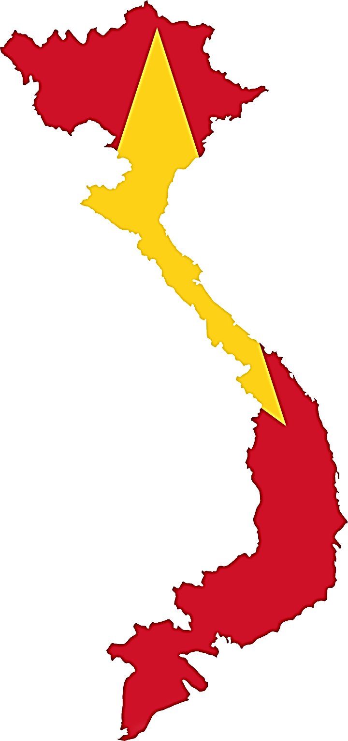
Vietnam
Type of Exhaustion | Exceptions to Exhaustion
International

Assessment of Parallel Imports
Can Unauthorized Parallel Imports Be Prevented From Entering Country?
Applicable Legislation
The Industrial Property Act of the Kingdom of Bhutan, 2001
Additional Comments
Under Article 125.2.b of Law on Intellectual property (IP Law) of Vietnam, the owner of an industrial property object shall not have the right to prevent others from circulating, importing, or exploiting the use of the products having been legally put into the marketplace, including foreign markets, except for products that are not permitted by the trademark owner(s) or the authorized persons/organizations to put into foreign markets. Accordingly, under the IP Law of Vietnam, an IPR owner cannot stop the parallel import goods (on the borders or in the market). In other words, parallel imports is allowed in Vietnam.

PI cannot be prevented from entering Vietnam on the basis of the IP laws. In accordance with Article 125.2(b) of the IP Law, Vietnam adopts the doctrine of international exhaustion of rights. That is to say, once the trade marked goods legally make debut in the market, including the foreign markets, the trademark owner cannot not prevent the subsequent importation and distribution of the goods based on the trademark rights. It means that based on its trade mark rights, the trade mark owner is not entitled to prevent companies from importing goods into Vietnam if the goods are genuine.
Does Customs Support/Assist Trademark Owner With PI?
In principle, parallel import does not constitute trademark infringement. Thus, customs could not rely on the IP laws to assist the trademark owner with PI.
Having said that, the trade mark owner can, in some cases, rely on other regulations such as labeling, importation of secondhand technology, or tax evasion, etc. to call on customs to block the inbound shipments. In practice, there are cases where the brand owner counts on the labeling regulations to seek customs seizure of parallel pharmaceutical imports.

What Procedures Are Available Once PI Enter Country?

As mentioned above, PI is legal in the aspect of the IP laws. Therefore, competent enforcement authorities cannot base on the IP laws to seize PI’s.

What Remedies Are Available?

Please see above.

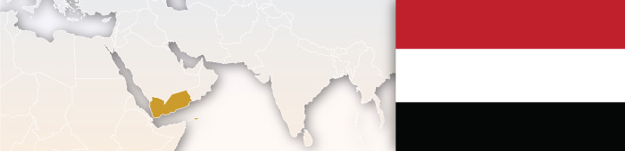

Yemen
Type of Exhaustion | Exceptions to Exhaustion
International | None.
Assessment of Parallel Imports
Can Unauthorized Parallel Imports Be Prevented From Entering Country?
Unauthorized PI is allowed to enter the country.
Applicable Legislation
‘Customs act’ (No. 14 of 1990) and ‘Trademarks law’ (No. 19 of 1994) of Yemen does not contain provisions to restrain parallel imports. ‘Law no. 23 of the year 1997’ regarding arrangement of agencies, branches of companies and foreign trade houses is also silent about the issue.

Does Customs Support/Assist Trademark Owner With PI?
There isn’t any law that would support trademark owners in customs against PI.

What Procedures Are Available Once PI Enter Country?

None.
What Remedies Are Available?

None.
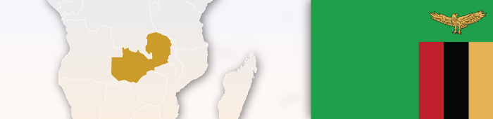

Zambia
Type of Exhaustion | Exceptions to Exhaustion
International

Assessment of Parallel Imports
Can Unauthorized Parallel Imports Be Prevented From Entering Country?
Unauthorized PI is allowed to enter the country.
Does Customs Support/Assist Trademark Owner With PI?
There isn’t any law that would support trademark owners in customs against PI.

What Procedures Are Available Once PI Enter Country?

None.
What Remedies Are Available?

None.

Zimbabwe
Type of Exhaustion | Exceptions to Exhaustion
International

Assessment of Parallel Imports
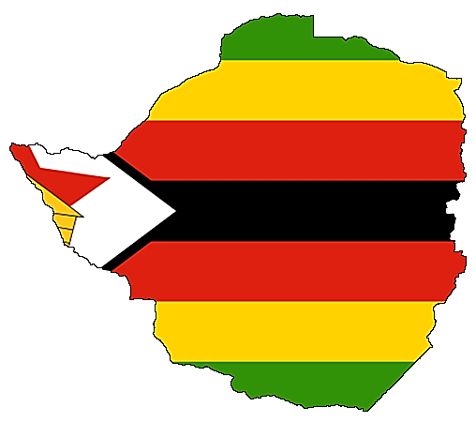
Can Unauthorized Parallel Imports Be Prevented From Entering Country?
Unauthorized PI is allowed to enter into the country.
Does Customs Support/Assist Trademark Owner With PI?
There isn’t any law that would support TM owners in customs against PI.

What Procedures Are Available Once PI Enter Country?

None.
What Remedies Are Available?

None.

